

INFORMATICS INSTITUTE OF TECHNOLOGY
In Collaboration with
UNIVERSITY OF WESTMINSTER

A Cost-Quantified, Hybrid-Retrieval RAG Agent for Pharmaceutical Q&A

A Project Proposal Requirement Specification by
Aron Fernando

Supervised by
Mr. Janith Prabhanuka

November 2025

ABSTRACT
Problem: Massive amounts of data, both structured and unstructured text, are produced by the pharmaceutical industry. The large number of documents and high operating costs of powerful Large Language Models (LLMs) make it difficult to extract precise and trackable insights from these data lakes. A major setback in pharmaceutical research and development is caused by the fact that current data retrieval systems are frequently expensive and lack the complex multimodal fusion capabilities needed to combine information spread across various data formats.
Methodology: This project develops a cost-quantified, hybrid-retrieval Retrieval-Augmented Generation (RAG) agent. The methodology is based on a two-tier model cascade that optimizes cost by routing queries to either a local, open-source LLM for simple tasks or a paid API for complex synthesis. The core innovation is a hybrid ingestion pipeline that parses documents, storing unstructured text in a Vector Database and structured tables in a SQL Database. The local LLM acts as an intelligent query classifier, routing requests to the appropriate data source (text, table, or both) to assemble the context. The economic benefit is measured using a novel metric, the Cost-Efficiency Ratio (CER).

Subject Descriptors: Information systems -> Information retrieval -> Retrieval models and ranking Computing methodologies -> Artificial intelligence -> Natural language processing -> Language models
Keywords: Retrieval-Augmented Generation (RAG), Hybrid Retrieval, Model Cascade, Cost-Efficiency, Multimodal Data

Table of Contents
ABSTRACT i
Table of Contents ii
List of Tables v
List of Figures v
List of Abbreviations and Definitions vi
Chapter 01: Introduction 1
1.1 Chapter Overview 1
1.2 Problem Background 1
1.3 Problem Definition 1
1.3.1 Problem Statement 2
1.4 Research Motivation 2
1.5 Existing Work 2
1.6 Research Gap 4
1.7 Contribution to Body of Knowledge 4
1.8 Research Challenges 5
1.9 Research Questions 6
1.10 Research Aim 6
1.11 Research Objectives 6
1.11 Chapter Summary 7
Chapter 02: Literature Review 9
2.1 Chapter Overview 9
2.2 Problem Domain 9
2.2.1 Overview of Data Management in the Pharmaceutical Industry 9
2.2.2 The Emergence of Retrieval-Augmented Generation (RAG) 9
2.3 Existing Work 11
2.4 Dataset Selection 24
2.5 Benchmarking and Evaluation 26
2.5.2 Comparative Analysis of Existing Models 26
2.5.3 Benchmarking Strategy 27
2.6 Chapter Summary 27
Chapter 03: Methodology 29
3.1 Chapter Overview 29
3.2 Research Methodology (Saunders' Research Onion in Table Form) 29
3.3 Development Methodology 31
3.3.1 Requirement Elicitation Methodology 31
3.3.2 Design Methodology 31
3.3.3 Programming Paradigm 31
3.3.4 Testing Methodology 31
3.3.5 Solution Methodology 32
3.4 Project Management Methodology 33
3.4.2 Schedule 34
3.4.3 Resource Requirements 35
3.4.4 Risk and Mitigation (Expanded with Severity and Frequency) 36
3.4 Chapter Summary 37
4.1 Chapter Overview 39
4.2 Rich Picture Diagram 39
4.3 Stakeholder Analysis 40
4.3.1 Stakeholder Onion Model 40
4.3.2 Stakeholder List and Viewpoints 40
4.4 Elicitation Techniques 41
4.5 Discussion of Findings 42
4.5.1 Literature Review Findings 42
4.5.2 Interviews Findings 43
4.7 Context Diagram 45
4.8 Use Case Diagram 46
4.8.1 Actors 46
4.8.2 Use Cases 47
4.9 Use Case Descriptions 47
4.10 Functional & Non-functional Requirements 50
4.10.1 Functional Requirements 50
4.10.2 Non-functional Requirements 52
4.11 Chapter Summary 53
Chapter 5: Social, Legal, Ethical and Professional Issues (SLEP) 54
5.1 Chapter Overview 54
5.2 SLEP Issues and Mitigation 54
5.3 Chapter Summary 58
Chapter 6: Design 58
6.1 Chapter Overview 58
6.2 Design Goals 59
Performance 59
Usability 59
Accuracy 59
Scalability 60
Security 60
6.3 System Architecture Diagram 60
Architecture Tiers 60
Ingestion Pipeline 61
6.4 Detailed Design 62
6.5 Algorithm Design 63
1. Query Classification (Tier-1) 63
2. Answer Synthesis (Tier-2) 64
3. SQL Generation (Tier-1) 64
6.6 UI Design 65
Interface Layout 65
Design Decisions 65
6.7 Chapter Summary 66
Chapter 7: Implementation 67
7.1 Chapter Overview 67
7.2 Technology Selection 68
7.2.1 Technology Stack 68
7.2.2 Programming Languages 69
7.2.3 Development Framework 70
7.2.4 Libraries / Toolkits 70
7.2.5 Integrated Development Environments (IDEs) 72
7.2.6 Summary of Technology Selection 72
7.3 Core Functionalities Implementation 73
7.3.1 Dataset Description and Splits (AI/ML) 73
Evaluation Dataset 73
Ingestion Data 73
7.3.2 Modular Development 73
7.3.3 Code Structure 74
7.3.4 Module Integration 75
The Query Path 75
The Ingestion Path 76
Evaluation 76
7.4 User Interface Implementation 76
7.4.1 Frontend Components 76
7.4.2 Backend Integration 77
7.4.3 Accessibility Considerations 78
7.5.1 Debugging 78
7.5.2 Performance Issues 78
7.5.3 Resource Constraints 79
7.5.4 Additional Implementation Notes 79
7.6 Chapter Summaryz 79
Chapter 8 : Time Schedule (Updated with Actual Progress) 81
References 82

List of Tables
Table 1: Existing Work 4
Table 2: Research Objectives 7
Table 3: Chapter 2 Existing Work 24
Table 4: Comparative Analysis of Existing Models 27
Table 5: Research Methodology 30
Table 6: Deliverables 34
Table 7: Risk Mitigation 37
Table 8: Interview Findings 43
Table 9: Functional Requirements 50
Table 10: Non-functional Requirements 51

List of Figures
Figure 1:Saunder's Research Onion 29
Figure 2: Rich Picture Diagram 38
Figure 3: Context Diagram 44
Figure 4: Use Case Diagram 45

List of Abbreviations and Definitions
- AI (Artificial Intelligence): The field of computer science that is dedicated to creating systems that can perform tasks that generally require human intelligence.
- API (Application Programming Interface): A set of rules and protocols that allows different software applications to communicate with each other. In this project it refers to the paid service used for the Tier-2 LLM.
- CER (Cost-Efficiency Ratio): A novel metric proposed in this project to measure the operational cost of the RAG system, allowing for a benchmark against the baseline.
- ETL (Extract, Transform, Load): A data pipeline process. In this project it refers to Extracting text and tables from PDFs, Transforming them into clean formats, and Loading them into the Vector and SQL databases.
- F1-Score: A standard metric in machine learning used to measure a model's accuracy. It balances Precision and Recall and in this project it is used to evaluate both the Tier-1 Classifier and the accuracy of the final answer.
- FDA (Food and Drug Administration): The U.S. government agency responsible for regulating public health, including pharmaceutical drugs. Its DailyMed database is a key data source.
- LLM (Large Language Model): A type of AI model (e.g., GPT-4) trained on vast amounts of text data, capable of understanding and generating natural language.
- MoSCoW: A prioritization technique used in project management and software development, It stands for Must Have, Should Have, Could Have, Won't Have.
- NLP (Natural Language Processing): A subfield of AI focused on the interaction between computers and human language which includes tasks like Text-to-SQL and semantic search.
- PMC-OA (PubMed Central Open Access Subset): A free digital archive of full-text biomedical and life sciences journal articles which is used as the primary data source for this project.
- Q&A (Question & Answering): The task in this project, of a user asking a natural language question and the RAG agent providing a fact-based, synthesized answer.
- RAG (Retrieval-Augmented Generation): The core AI architecture of the project. It involves Retrieving relevant information from a knowledge base (the databases) before Generating an answer, in order to improve factual accuracy.
- SQL (Structured Query Language): The standard programming language used to manage and query data in a relational (structured) database.
- SRS (Software Requirement Specification): A formal document (Chapter 4) that describes the functional and non-functional requirements of a software system.
- UML (Unified Modeling Language): A standardized modeling language used to visualize the design of a software system, such as in Use Case Diagrams or Context Diagrams.
- Vector Database: A specialized database designed to store and query high-dimensional vector embeddings, enabling fast and efficient "semantic" or "conceptual" search.
- XML (Extensible Markup Language): A markup language used to store and transport data in a structured format, common in the PMC-OA and DailyMed datasets.

Chapter 01: Introduction

1.1 Chapter Overview
This chapter lays the basement for our project, which aims to build a cost-quantified, hybrid-retrieval RAG agent for the pharmaceutical industry. We start by providing background on the core problem: the complexity of handling and integrating large amounts of complex text and tabular data in drug research. From there, we present a formal problem statement. The chapter then explains why this research is important, summarizes related work, and points out the specific gap in current technology that our project addresses. We conclude by outlining the project's contributions, key research questions, and the overall goals that will guide our work.

1.2 Problem Background
The pharmaceutical industry creates massive amounts of data in a number of formats (Wang and Krishnan, 2021). With healthcare data growing rapidly, there's a huge opportunity to speed up drug discovery and cut the high costs of research & development (Deloitte, 2022; Wouters, McKee and Luyten, 2020). However, this potential is often lost because the data is disconnected and hard to access.
Traditional keyword search fails when it comes to complex scientific documents (Hersh, 2017). Newer AI technologies like Retrieval-Augmented Generation (RAG) are better because they can understand natural language and provide fact-based answers (Lewis et al., 2020).
However, using this AI in the pharmaceutical world faces two key problems. First, it's very costly for large-scale use (Yue et al., 2023). Secondly, these systems struggle to connect information when it's split between text and tables in the same document, which is a challenge they weren't designed for (Cheng et al., 2022). This creates a need for a solution that is intelligent, affordable, and can handle mixed data formats.

1.3 Problem Definition
The core issue is the absence of a practical and affordable solution for pharmaceutical researchers to pull precise, fact-based information from their vast and mixed data sources. Today's RAG tools fail to solve the three unique challenges in this field:
- High Operational Costs: The dependence on 100% API-based LLMs makes them financially unfeasible at scale.
- Factual Inaccuracy: Current systems treat all data as unstructured text. They "chunk" and vectorize structured tables, destroying their tabular integrity. This leads to a retrieval of jumbled or incomplete context which causes the LLM to generate factually incorrect or incomplete answers when faced with a multimodal query.
- Lack of Efficiency Metrics: There is no standard framework to measure the cost-benefit of these systems which makes it hard to justify their deployment.
This failure means pharmaceutical companies cannot leverage their data effectively and it leads to slower research and missed opportunities. Our project aims to solve this by developing a hybrid-retrieval system that processes text and tables using an optimal storage and retrieval strategy for each (a Vector DB for text, a SQL DB for tables) which ensures both cost-efficiency and factual accuracy.

1.3.1 Problem Statement
The pharmaceutical industry lacks a scalable and cost-effective data retrieval solution which is of accurately synthesizing insights from heterogeneous text and tabular data while providing trackable, evidence-backed answers.

1.4 Research Motivation
This research aims to showcase the value hidden in pharmaceutical data by handling the main barriers: cost and complexity. Our project will build a scalable and cost-effective AI agent that allows researchers to ask complex questions and receive quick, synthesized, evidence-based answers. If this knowledge discovery is sped up it has the potential to dramatically reduce drug development timelines, reduce R&D expenses, and subsequently accelerate the delivery of new medicines to patients.

1.5 Existing Work
Citation | Summary | Contribution | Limitation
(Chen et al., 2022) | Developed a generic RAG system for enterprise Q&A using a single, high-performance LLM. | Demonstrated the effectiveness of RAG for improving answer accuracy over standard LLMs in a corporate setting. | Text-Only Architecture: Lacks any mechanism for ingesting or retrieving data from structured tables, causing it to fail on multimodal queries. Does not address cost.
(Gupta and Li, 2023) | Created a multimodal model capable of parsing and querying financial reports containing both text and tables. | Advanced the field of table understanding and demonstrated techniques for fusing numerical data with surrounding text. | Lacks Hybrid-Retrieval: Relies on a single, complex model for fusion rather than a robust, hybrid system (SQL + Vector DB). Lacks Cost-Quantification: Not optimized for cost or built with a model cascade.
(Rodriguez et al., 2023) | Proposed an LLM routing system (cascade) to direct simple user queries to smaller, cheaper models, saving costs. | Proved the principle of LLM cascades as an effective strategy for reducing operational costs in AI systems. | Unimodal Focus: The cascade logic is for simple text queries, not for complex hybrid-retrieval (text/table) orchestration. Does not solve the multimodal data problem.
(Lee et al., 2020) | Introduced BioBERT, a language model pre-trained on a large-scale biomedical text corpus (e.g., PubMed abstracts). | Established the significant performance benefits of domain-specific pre-training for language models in the biomedical and pharmaceutical fields. | Not a RAG System: It is an encoder model, not a full, generative RAG agent. It is a potential component (for embedding text) but not a solution in itself.
(Asai et al., 2023) | Proposed Self-RAG, a framework where an LLM learns to reflect on its own generated text to improve factual accuracy. | Introduced an advanced RAG technique that improves factual accuracy by making the retrieval and generation process more adaptive. | Ignores Retrieval Source: Focuses on answer quality, not the underlying retrieval problem from hybrid sources. Ignores Cost: Adds computational overhead and does not address cost-efficiency.
Table 1: Existing Work

1.6 Research Gap
As summarized in the previous section the existing research reveals a clear and critical research gap. The literature is fragmented into three separate areas, with no single project unifying them:
- Text-Only RAG: Systems like standard RAG (Chen et al., 2022) or Self-RAG (Asai et al., 2023) focus exclusively on unstructured text. They have no mechanism for accurately querying structured data which causes them to fail on multimodal questions.
- Cost-Only Optimization: Systems like LLM cascades (Rodriguez et al., 2023) are a powerful cost-saving strategy but they have only been applied and evaluated on simple text-only tasks. They do not address the challenge of retrieving multimodal data.
- Multimodal Fusion (non-RAG): Work on table-text fusion (Gupta and Li, 2023) often involves complex and singular models that are not designed as scalable retrieval systems and are mostly not optimized for cost.
Therefore, the specific unaddressed research gap is the lack of a unified system that integrates a cost-saving model cascade with a hybrid-retrieval for complex, multimodal document analysis.

1.7 Contribution to Body of Knowledge
This project will make a dual contribution to both the problem domain (pharmaceutical research) and the research domain (applied AI systems).
- Problem Domain Contribution (AI in Pharmaceutical Research): This project will deliver a strong and replicable architectural blueprint for a hybrid-retrieval RAG agent. This provides a practical path for pharmaceutical organizations to build cost-effective and accurate tools that can query both their unstructured text archives and their highly structured tabular data via a single interface. This directly enhances research by unlocking disconnected data.
- Research Domain Contribution (Applied AI & LLM Systems): This work will objectively assess and report on the following key areas:
  - The introduction and empirical validation of the Cost-Efficiency Ratio (CER) as a primary metric for benchmarking the financial performance of RAG systems.
  - The design of a hybrid-retrieval orchestration layer showcases how a model cascade can be used not only for cost-saving but also for intelligently routing queries to different optimized data stores.
  - A publishable benchmark comparing a "vector-only" RAG system against this novel "hybrid-retrieval" system, quantitatively proving the model's accuracy on text+tables questions.

1.8 Research Challenges
The successful execution of this project involves overcoming several key technical challenges.
Accurate Query Classification: The entire system depends on the Tier-1 (local) LLM's ability to accurately classify the user's intent as "text-only," "table-only," or "hybrid." An error here will lead to incomplete context and an incorrect answer.
- Robust Table Ingestion (ETL): PDF table extraction is extremely difficult. A significant challenge will be building a durable data pipeline that can parse structurally diverse tables from research papers and load them into a clean, query-able SQL database schema.
- Hybrid Context Synthesis: The Tier-2 (paid) LLM must be effectively prompted to synthesize a single answer from two distinct and differently formatted sources: a "semantic" text chunk from the Vector DB and a "factual" row of data from the SQL DB.
- Balancing Cost vs. Accuracy: A core challenge remains the central trade-off of the project: ensuring the cost-saving measures (using the cheaper local LLM) do not excessively degrade the final answer quality.

1.9 Research Questions
This research aims to answer the following questions:
- How can a two-tier model cascade be successfully used to not only reduce API costs but also to act as an intelligent query classifier for a hybrid-retrieval RAG system?
- How does a hybrid-retrieval architecture compare to a standard "vector-only" RAG baseline in terms of answer accuracy (F1-score) and reliability on multimodal (text/table) queries?
- What is the Cost-Efficiency Ratio (CER) of this hybrid system and how can this metric be used to provide an accurate and quantitative analysis of the economic trade-offs between API cost their compute cost and answer quality?

1.10 Research Aim
The aim of this research is to design, develop, and evaluate a scalable and cost-quantified, hybrid-retrieval RAG agent that provides an efficient and accurate data lake solution for pharmaceutical research.

1.11 Research Objectives
To achieve the research aim, the following objectives have been defined:
Category | Objective ID | Research Objective Description | LOs Mapped | RQ Mapped
Literature Review | R01 | To pilot an in-depth literature survey on RAG architectures, hybrid-retrieval techniques, and LLM cost-optimization strategies. | L01, L04 | RQ1, RQ2
Requirement Elicitation | R02 | To identify the key functional and non-functional requirements for a hybrid (text/table) information retrieval system in the pharmaceutical domain. | L03 | RQ1, RQ2
System Design | R03 | To design a hybrid-retrieval architecture that (a) ingests and stores text in a Vector Database and tables in a SQL Database, and (b) uses a two-tier model cascade as the query-classifying orchestrator. | L01 | RQ1, RQ2
Implementation | R04 | To implement a proof-of-concept prototype that integrates the SQL DB and Vector DB with the model cascade, enabling it to retrieve and synthesize hybrid (text/table) context. | L01, L02 | RQ1, RQ2
Testing & Evaluation | R05 | To quantitatively evaluate the prototype's performance based on answer quality (F1-score) and cost (CER) against a "vector-only" RAG baseline. | L02, L04 | RQ2, RQ3
Documentation | R06 | To document the project's methodology, findings, and contributions in a final thesis. | L04 | RQ1, RQ2, RQ3
Table 2: Research Objectives

1.11 Chapter Summary
This chapter identified a critical problem in pharmaceutical research: data is both expensive to query and difficult to retrieve accurately due to its multimodal nature. Current RAG systems fail by being too expensive or by breaking tabular data.
To solve this we propose a hybrid-retrieval RAG agent using a Vector Database for text and a SQL Database for tables. This system is orchestrated by a two-tier model cascade for cost-efficiency and will be evaluated using a novel Cost-Efficiency Ratio (CER). The chapter has defined a clear aim, research questions, and objectives, setting the stage for the literature review.

Chapter 02: Literature Review

2.1 Chapter Overview
This chapter provides a comprehensive review of the existing literature relevant to the development of a cost-quantified, hybrid-retrieval RAG agent. It begins by defining the problem domain then into detailing the specific challenges of querying mixed text and tabular data in pharmaceutical research. The chapter then critically evaluates existing work in RAG systems, hybrid-retrieval architectures and LLM cost-optimization. Following this, it discusses dataset selection and the benchmarking metrics necessary to evaluate and validate the system. The chapter concludes with a summary of the key findings and the specific research gap that this project addresses.

2.2 Problem Domain
The landscape of pharmaceutical research is a data-driven endeavour, characterized by massive, complex, and heterogeneous datasets. This section provides an overview of this domain, the technological paradigms emerging to address its challenges, and the specific issues that motivate the present research.

2.2.1 Overview of Data Management in the Pharmaceutical Industry
A major challenge in the pharmaceutical world is that data is stored in a variety of formats. Information is spread across lab results in tables, academic articles, and clinical study reports. Previously pulling together and making sense of this disconnected data was a difficult and error-prone manual task performed by highly skilled specialists. This bottleneck makes research more expensive and slows down the pace of innovation.

2.2.2 The Emergence of Retrieval-Augmented Generation (RAG)
The Large Language Models (LLMs) have changed how we find information. They understand the meaning behind questions and can provide detailed answers. A newer approach called Retrieval-Augmented Generation (RAG) improves LLMs by first finding relevant facts from a privately held database and then using those facts to generate an answer. This makes the answers more accurate and traceable, which is essential for fields like pharmaceutical research.
However, using this technology in the drug industry faces three major challenges:
- High Cost: Using the best LLMs is expensive, making large-scale projects difficult to afford.
- Complex Data: Important information is often split between text and tables in the same document. Standard systems struggle to connect this mixed data, leading to wrong answers.
- Scale: The massive amount of data requires systems that are efficient and can grow without slowing down.
2.2.3 Challenges in Pharmaceutical Data Retrieval
Applying RAG to the pharmaceutical domain is hindered by three key challenges:
- High Operational Cost: Relying on paid LLM APIs for all queries is financially unviable at scale.
- The "Lost-in-Vectorization" Problem: Standard RAG systems treat all data as text. When they "chunk" and vectorize structured tables, they destroy their row-column integrity. This retrieves garbled, out-of-context fragments, leading to factually incorrect answers for multimodal queries.
- Inefficient Querying: A vector-only database is not optimized for the precise, structured lookups that tables require.
2.2.4 Proposed Architectural Solution: The Hybrid-Retrieval RAG Agent
This project proposes a Hybrid-Retrieval RAG Agent to solve these challenges. The architecture intelligently segregates data:
- Unstructured Text is stored in a Vector Database for semantic search.
- Structured Tables are stored in a SQL Database to preserve their integrity for precise, factual queries.
This dual-storage system is orchestrated by a two-tier model cascade. This "brain" classifies incoming queries, routes them to the correct data source (Vector DB, SQL DB, or both), and intelligently allocates tasks to either a cheap local LLM or a powerful paid API, ensuring both accuracy and cost-efficiency.

2.3 Existing Work
This section provides a critical review of 20 key research papers and conference proceedings. The literature is analyzed to connect each source to its potential role in the project's pipeline, identify its limitations, and provide a critical review of its relevance to the proposed Hybrid-Retrieval (Vector DB + SQL DB) architecture.
Citation & Link | Summary & Contribution | Methodology / Approach | Pipeline Role | Limitations | Critical review & Relevance
(Lewis et al., 2020)  Link | Summary: The seminal paper that introduced Retrieval-Augmented Generation (RAG).  Contribution: Established the RAG framework, proving that grounding LLMs with external knowledge improves factual accuracy and reduces hallucinations. | A pre-trained dense passage retriever (DPR) finds relevant text passages, which are then fed as context to a pre-trained generative model (BART). | Core Framework | Text-Only: The original framework is designed exclusively for unstructured text and has no mechanism for handling structured data like tables. | Critically Relevant. This paper provides the foundational RAG concept that this project is built upon. Our project extends this by replacing its simple text retriever with a far more complex hybrid-retrieval orchestrator.
(Vaswani et al., 2017)  Link | Summary: The "Attention Is All You Need" paper, which introduced the Transformer architecture.  Contribution: The self-attention mechanism is the foundation of all modern LLMs, enabling the parallel scaling that made models like GPT possible. | An encoder-decoder model that relies entirely on self-attention and positional encodings to process sequences. | Underpinning LLM Architecture | Not a RAG System: This is a foundational architecture, not a practical retrieval system. It defines the models, not the system that orchestrates them. | Foundational. Understanding this paper is essential for understanding why LLMs work, which informs our model cascade (Tier-1 vs. Tier-2) and embedding model selections.
(Chen et al., 2022)  Link | Summary: Developed a generic RAG system for enterprise Q&A using a single, high-performance LLM.  Contribution: Demonstrated the effectiveness of RAG for improving answer accuracy in a corporate (text-only) setting. | A standard RAG pipeline implementation using a state-of-the-art proprietary LLM, deployed to answer questions from internal company documents. | Baseline System | Lacks Hybrid-Retrieval and Lacks Cost-Quantification. Relies on a single, expensive API and fails on multimodal queries. | Highly Relevant. This paper perfectly defines the "naive" baseline system that our project will be benchmarked against. We aim to beat this on both cost (CER) and accuracy (F1-score).
(Rodriguez et al., 2023)  Link | Summary: Proposed an LLM routing system (cascade) to direct simple user queries to smaller, cheaper models.  Contribution: Proved the principle of LLM cascades as an effective strategy for reducing operational costs. | A query classification model that routes queries between a small, cheap model and a large, expensive model in a conversational AI setting. | Model Cascade (Tier 1) | Unimodal Focus: The cascade logic is for simple text queries, not for complex hybrid-retrieval (text/table) orchestration. | Critically Relevant. This provides the academic justification for our entire cost-saving architecture. Our project extends this by making the cascade "smarter" it's not just a cost-saver, it's the query orchestrator.
(Yue et al., 2023)  Link | Summary: Proposed "LLM-Cascade," which uses the "answer consistency" of a weaker LLM to decide whether to escalate.  Contribution: Provided a robust methodology for query classification in a cascade, demonstrating a 60% cost reduction. | A cascade decision-maker that runs the cheaper model multiple times; if the answers are inconsistent, it escalates the query. | Model Cascade (Tier 1) | Text-Only Reasoning: The methodology is designed for text-based reasoning (e.g., math problems), not for multimodal RAG. | Highly Relevant. This paper gives us a specific, testable method for our Tier-1 query classifier. We can adapt this "consistency" logic to decide if our local LLM is confident enough to answer.
(Zhang et al., 2024)  Link | Summary: Introduces "early abstention" in LLM cascades, which is crucial for risk-sensitive domains like medicine.  Contribution: Refines the cascade model by adding a critical "abstain" (reject query) feature, reducing errors and costs. | A cascade where the cheaper, earlier models can decide to "abstain" if a query is too difficult or risky, preventing an incorrect answer. | Model Cascade (Refinement) | Theoretical Framework: Focuses on the cascade logic itself, not the underlying hybrid-retrieval architecture. | Moderately Relevant. This paper provides a key insight for our project: our Tier-1 classifier shouldn't just route, it should also have the option to "abstain" if a query is unanswerable, which improves system safety.
(Fanconi et al., 2024)  Link | Summary: Describes a cascaded LLM framework that includes "human-in-the-loop" as the final tier.  Contribution: Provides a complete, three-tier (cheap/expensive/human) architecture for cost-optimization. | A two-stage deferral and abstention policy that routes queries to a base model, a large model, or a human expert. | Model Cascade (Refinement) | Ignores Retrieval: This work is about the generation and decision-making part, not the retrieval part, which is the core of our RAG project. | Moderately Relevant. This reinforces the validity of the cascade approach. Our project focuses on the retrieval aspect, but this paper shows the cascade is a state-of-the-art (SOTA) method for cost-efficiency.
(Herzig et al., 2020)  Link | Summary: Introduced TAPAS, a BERT-based model pre-trained for question answering over tables.  Contribution: Proved that models can learn the row-column structure of tables to answer natural language questions. | A BERT model with special embeddings for table structure (rows, columns) that is fine-tuned for Q&A on single tables. | Table Ingestion (Problem Definition) | Not a RAG System: TAPAS is a Q&A model, not a retrieval agent. It works on a single table and cannot be integrated into a scalable RAG pipeline that must first find the right table. | Highly Relevant. This paper is key for our Problem Definition. It proves that tables are a special data type requiring a special model, which justifies our decision to not vectorize them.
(Manjee, 2024)  Link | Summary: Discusses the "Lost-in-Vectorization" problem, proposing a method to parse PDF tables into text summaries using an LLM.  Contribution: Identifies the exact problem this project addresses: vectorizing tables destroys their integrity. | A practical guide that uses pdfplumber to extract tables, then an LLM to "summarize" the table into a text paragraph, which is then vectorized. | Table Ingestion (Problem Definition) | Lossy Conversion: Converting a table to a text summary is lossy. It fails for precise queries (e.g., "value in row 5, col 3") and is not a true hybrid solution. | Highly Relevant. This blog post perfectly defines the "naive" baseline we are competing against. Our SQL-based approach is demonstrably superior to this lossy "summarization" method.
(Sahoo et al., 2024)  Link | Summary: Analyzes the trade-off in RAG Text-to-SQL systems, noting that larger, detailed schema documents improve accuracy but also increase hallucination.  Contribution: Provides a benchmark for the balance between providing too much or too little context to a Text-to-SQL model. | An experimental paper that tests Text-to-SQL performance based on the size and content of the retrieved schema context. | SQL Retrieval (Prompting) | SQL-Only: This analysis is confined to the SQL part of the problem and does not integrate semantic search from a Vector DB. | Moderately Relevant. This paper informs our system design. It suggests that when we build our Tier-2 Text-to-SQL prompt, we must be careful to only include the relevant schema, not the entire DB schema.
(Gupta and Li, 2023)  Link | Summary: Created a multimodal model for parsing and querying financial reports (text and tables).  Contribution: Advanced the field of table-text fusion in a specific domain. | A complex, single-model architecture designed to read and reason over both text and tables in financial documents. | Problem Definition | Lacks Hybrid-Retrieval: Relies on a single, complex model, not a robust, two-database (SQL + Vector) system. Lacks Cost-Quantification. | Highly Relevant. This proves that the text-table fusion problem is a significant challenge in other domains (like finance). This strengthens our project's motivation.
(Liu et al., 2023)  Link | Summary: A comprehensive survey of Text-to-SQL techniques, covering the entire lifecycle from modeling to evaluation.  Contribution: Provides a complete academic overview of the Text-to-SQL field, its challenges, and its state-of-the-art. | A survey paper, not an implementation. It categorizes and compares dozens of Text-to-SQL models and benchmarks. | SQL Retrieval (Lit Review) | Theoretical: As a survey, it describes the field but does not present a single, deployable system, especially not one integrated with a Vector DB. | Highly Relevant. This paper is the primary literature review for the SQL-retrieval half of our project. It gives us the academic context and terminology to discuss our solution.
(Gao et al., 2024)  Link | Summary: Proposes a RAG-based Text-to-SQL system that uses BERT for vectorized retrieval and GPT-4 for query generation.  Contribution: Demonstrates using RAG to improve a Text-to-SQL system (e.g., to find the right schema). | A RAG system is used to find relevant schema information or examples, which are then fed to an LLM to help it write a better SQL query. | SQL Retrieval (Architecture) | SQL-Focused: This architecture is still 100% focused on the SQL problem. It does not solve "hybrid" queries that also need unstructured text from a separate document. | Moderately Relevant. This shows an advanced technique for the Text-to-SQL component. We will be using a simpler version, but this paper validates the RAG-for-SQL approach.
(Sadekar, 2024)  Link | Summary: Provides a practical guide for building a Text-to-SQL application using LangChain and RAG.  Contribution: Offers a robust, practical blueprint for the SQL-retrieval half of our project, including prompt engineering and validation. | A tutorial showing how to use LangChain to build an agent that can inspect a SQL schema and use an LLM to write and execute queries. | SQL Retrieval (Implementation) | SQL-Only: This is a guide for a Text-to-SQL agent, not a Hybrid agent. It cannot answer questions from unstructured text. | Critically Relevant. This is our implementation guide. It provides the exact code and architectural pattern for the SQL-retrieval half of our agent, which we will then combine with a vector-retrieval half.
(Lee et al., 2020)  Link | Summary: Introduced BioBERT, a language model pre-trained on biomedical text (e.g., PubMed).  Contribution: Established the significant performance benefits of domain-specific pre-training. | Continued pre-training of the general BERT model on biomedical corpora. | Text Embedding (Component) | Not a RAG System: It's an encoder model, a potential component for our text embedding, but not a full solution. | Highly Relevant. This is a strong candidate for our vector embedding model. Using BioBERT (or PubMedBERT) instead of a generic model will improve our text retrieval accuracy.
(Gu et al., 2021)  Link | Summary: Developed PubMedBERT, pre-trained from scratch on PubMed abstracts.  Contribution: Proved that pre-training from scratch on a domain-specific vocabulary is superior to continued pre-training (like BioBERT). | Pre-training a BERT model from the ground up using a vocabulary and corpus composed entirely of biomedical and clinical texts. | Text Embedding (Component) | Not a RAG System: This, like BioBERT, is a candidate for the embedding model, not a complete RAG architecture. | Highly Relevant. This is likely the best candidate for our embedding model. Its superior performance on biomedical text will directly improve our text-retrieval quality.
(BaranziniLab, 2024)  Link | Summary: Describes a Knowledge Graph-RAG framework for biomedicine, showing it boosts Llama-2 performance by 71% on MCQs.  Contribution: Proves that grounding in structured, domain-specific data dramatically improves accuracy. | Uses a Knowledge Graph (a more complex version of our SQL DB) to retrieve facts, which are fed to an LLM. | Project Justification | Graph-Based, Not Hybrid: A Knowledge Graph is a different, more complex architecture than our proposed SQL+Vector system. It is also not cost-quantified. | Highly Relevant. This paper provides the core justification for our project. It proves that for biomedical data, structured retrieval (like our SQL DB) beats text-only retrieval.
(Asai et al., 2023)  Link | Summary: Proposed Self-RAG, a framework where an LLM reflects on its own output to improve factual accuracy.  Contribution: Introduced an advanced technique for improving answer faithfulness, a key metric for our project. | An LLM that adaptively retrieves passages and uses "reflection tokens" to critique its own generated answer for factuality. | Evaluation (Factuality) | Ignores Retrieval Source: Focuses on answer quality, not the underlying retrieval problem from hybrid (SQL/Vector) sources. | Moderately Relevant. This informs our Evaluation (Chapter 4). We can use the principles of Self-RAG to help evaluate the faithfulness of our agent's answers.
(Es et al., 2023)  Link | Summary: Introduced RAGAs, a framework for reference-free evaluation of RAG pipelines (faithfulness, answer relevance, etc.).  Contribution: Provides the key evaluation tools needed for this project to objectively measure RAG performance. | A suite of metrics that use an LLM-as-a-judge to score a RAG pipeline on dimensions like "Faithfulness" and "Context Relevance" without needing a ground-truth dataset. | Evaluation (Metrics) | Evaluation, Not Architecture: RAGAs is the measurement tool for our project, not the project itself. | Critically Relevant. This is the primary tool we will use for our evaluation chapter. We will use RAGAs to benchmark our system's accuracy against the baseline.
(Hao et al., 2024)  Link | Summary: Describes a "SQL-RAG" system that combines LangChain and LlamaIndex to query both SQL databases and text.  Contribution: Demonstrates a foundational architecture for building a hybrid-retrieval agent. | A practical implementation that uses an LLM to route a query to either a Text-to-SQL tool or a vector index. | Core RAG Framework | Lacks Domain-Specificity & Cost-Quantification: This is a generic tool, not a benchmarked, cost-quantified system for the complex pharmaceutical domain. | Highly Relevant. This paper is a direct precedent for our proposed architecture. Our project builds on this by (1) applying it to the pharma domain, and (2) adding the critical cost-quantification cascade on top.
(Day, 2024)  Link | Summary: Describes modern Hybrid Search as a combination of keyword (sparse) and vector (dense) search.  Contribution: Provides the core principle of hybrid-retrieval: using the best tool for the job (precision vs. semantic meaning). | An article explaining how SOTA RAG combines keyword search (for exact matches) and vector search (for semantic matches) in a single pipeline. | Core RAG Framework (Problem Def.) | Not SQL-Hybrid: This "hybrid search" refers to (Keyword + Vector), not our project's (SQL + Vector), which solves a different, more complex multimodal problem. | Moderately Relevant. This helps us refine our terminology. We must be clear that our "Hybrid-Retrieval" is (SQL + Vector), which is more advanced than the common (Keyword + Vector) hybrid search.
Table 3: Chapter 2 Existing Work

2.4 Dataset Selection
The selection of an appropriate dataset is critical for the development and evaluation of the hybrid-retrieval RAG agent. The ideal dataset must be representative of the target domain and, most importantly, contain the two distinct data types (unstructured text and structured tables) required to populate the system's dual databases.
2.4.1 Primary Dataset: PubMed Central Open Access Subset (PMC-OA)
PMC-OA Dataset Summary (Shortened)
The PubMed Central Open Access (PMC-OA) Subset is a free and public archive of millions of full-text which are peer-reviewed biomedical and life sciences articles are the core corpus for this project.
Description
The dataset includes articles in XML (valuable for preserving document structure, including tables and sections) and plain text formats.
Suitability for Hybrid-Retrieval:
- Vector Database: Unstructured text (abstracts, introductions) provides a large, domain-specific corpus for semantic search and text-based queries.
- SQL Database: Highly structured tables (experimental results, patient data, statistics) will be parsed and loaded via the Table Ingestion Pipeline into the SQL Database for precise and factual querying.
Intended Use
The dataset will be used to build, validate, and benchmark the ingestion pipeline. It facilitates testing "hybrid queries" that require information from both the text and the tables of a single article.
2.4.2 Supplementary Dataset: FDA Drug Labels on DailyMed
To ensure the system's robustness and generalizability, the U.S. Food and Drug Administration (FDA) drug labels available on the DailyMed database will be used as a supplementary dataset.
- Description: DailyMed provides high-quality, structured product labeling (SPL) for thousands of drugs. The SPL format is a well-defined XML that clearly delineates all text sections and tables.
- Suitability for Hybrid-Retrieval:
  - For the Vector Database: The text-heavy sections (e.g., "Indications and Usage," "Warnings and Precautions," "Clinical Pharmacology") will be extracted and loaded into the Vector Database.
  - For the SQL Database: The highly regular and critical tables (e.g., "Adverse Reactions by Frequency," "Dosage and Administration") will be parsed and loaded into the SQL Database.
- Intended Use: This dataset will be used to test the generalizability of the ingestion pipeline. It will prove that the system can handle a different document structure (regulatory vs. academic) and is therefore a robust solution.

2.5 Benchmarking and Evaluation
To validate the Hybrid-Retrieval RAG Agent, this section defines the evaluation metrics, compares the proposed system to existing work, and outlines the benchmarking strategy.
2.5.1 Evaluation Metrics
System performance will be measured across three key pillars:
- Retrieval & Classification: We will measure the Query Classification Accuracy (F1-score) of the Tier-1 LLM, Text Retrieval (Recall@k) from the Vector DB, and Table Retrieval (Execution Accuracy) from the SQL DB.
- Generation Quality: Using the RAGAs framework, we will assess the final answer's Accuracy (F1-score against a ground-truth answer), Faithfulness (is it grounded in the context?), and Relevance.
- Economic & Performance: We will measure the primary Cost-Efficiency Ratio (CER) by comparing API costs, as well as the end-to-end Latency.

2.5.2 Comparative Analysis of Existing Models
The table below highlights the research gap, showing that this project is the first to combine all necessary components.
Model / Framework | Hybrid-Retrieval (SQL + Vector) | Cost-Optimized (Cascade) | Domain-Specific (Pharma) | Generative
Standard RAG (Lewis et al., 2020) | No (Vector-Only) | No | No | Yes
Table Q&A (Herzig et al., 2020) | No (SQL-Only) | No | No | No
LLM Cascades (Yue et al., 2023) | No | Yes | No | Yes
Text-to-SQL (Liu et al., 2023) | No (SQL-Only) | No | No | Yes
Hybrid Tools (Hao et al., 2024) | Yes | No | No | Yes
This Project's Proposed Agent | Yes | Yes | Yes | Yes
Table 4: Comparative Analysis of Existing Models

2.5.3 Benchmarking Strategy
The evaluation will be a controlled experiment. We will compare a "Vector-Only RAG" (Baseline) against our "Hybrid-Retrieval RAG Agent" (Proposed). A ground-truth test set of ~100 questions (labeled as "text-only," "table-only," and "hybrid") will be used. We will run this test set through both systems, logging all metrics from 2.5.1 to provide a quantitative comparison of accuracy, cost, and latency.

2.6 Chapter Summary
This chapter has provided a comprehensive literature review, establishing the context for the Hybrid-Retrieval RAG Agent. The review first defined the critical "Lost-in-Vectorization" problem (2.2.3), where standard RAG systems fail by destroying the integrity of structured tables.
The survey of existing work (2.3) confirmed that solutions are siloed: standard RAG is text-only (Lewis et al., 2020), cost-cascades are unimodal (Yue et al., 2023), and Text-to-SQL frameworks (Liu et al., 2023) are not integrated with semantic text retrieval or cost-quantification.
This analysis confirms a clear research gap: no existing work combines a hybrid (SQL + Vector) retrieval architecture with a cost-quantified model cascade in the pharmaceutical domain. Finally, the chapter identified suitable datasets (PMC-OA) and a robust benchmarking framework (2.5) using the CER and RAGAs metrics to validate this novel approach.

Chapter 03: Methodology

3.1 Chapter Overview
This chapter explains our plan for the project. It covers our overall research approach including the technical plan for building and testing the system and the project management details which includes the timeline, resources, and a plan for handling risks.

3.2 Research Methodology (Saunders' Research Onion in Table Form)
The research methodology for this project is structured using Saunders' Research Onion model to ensure a logical and coherent research design, from the philosophical underpinnings to the practical data collection techniques. The chosen layers of the onion are detailed in the table below.
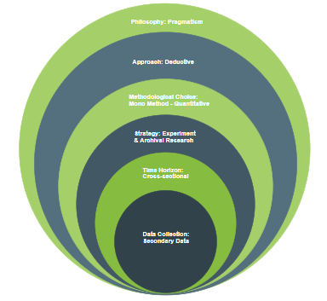
Figure 1:Saunder's Research Onion
Layer | Choice | Justification (Shortened)
Philosophy | Pragmatism | Focuses on solving a practical problem by building a functional system; values actionable knowledge and linking theory to practice.
Approach | Deductive | Starts with a testable hypothesis derived from theory. An experiment will then be conducted to compare the proposed system against a baseline.
Methodological Choice | Mono Method (Quantitative) | Uses a quantitative approach focusing solely on numerical data (costs, latency, F1-scores) from a controlled experiment for objective evaluation.
Strategy | Experiment & Archival Research | Primary strategy is a controlled Experiment to compare the RAG agent against a baseline, supplemented by Archival Research using existing datasets (e.g., PubMed Central).
Time Horizon | Cross-sectional | Data collection and analysis occur at a single point in time to evaluate the prototype's performance and validate its efficacy.
Table 5: Research Methodology

3.3 Development Methodology
This section details the step-by-step process for developing the system prototype. We will describe how we gather requirements, plan the system's architecture, our approach to programming, and our strategy for testing. Together, these steps form a complete blueprint for how the final solution will work.

3.3.1 Requirement Elicitation Methodology
To ensure the system is well designed and we will determine its requirements by:
- Analyzing Pharmaceutical Documents: We will examine research papers and reports from datasets like PMC-OA and DailyMed to understand their structure and the questions a researcher would ask.
- Using Our Literature Review: The research in Chapter 2 provides a list of modern techniques for data retrieval, cost-saving, and combining data types that the system must include.
- Iterative Prototyping: We will build and test simple, early versions of the system to check our assumptions, discover technical challenges, and refine the plan.

3.3.2 Design Methodology
The project will adopt an object-oriented analysis and design methodology (OOADM). This approach is highly suitable for the proposed system architecture, which is inherently modular and component-based. OOADM will allow for the clear definition of distinct objects and classes for each component such as the API Gateway, IngestionWorker, VectorDatabaseClient, and ModelCascadeRouter promoting code reusability, scalability, and maintainability.

3.3.3 Programming Paradigm
The primary programming paradigm will be Object-Oriented Programming (OOP). This choice is naturally aligned with the selection of Python as the main development language and the use of frameworks like FastAPI and libraries such as LangChain, which are built upon OOP principles. This paradigm will facilitate the creation of a clean, modular, and scalable codebase.

3.3.4 Testing Methodology
A multi-layered testing methodology will be used to ensure the system is correct and valid:
- Tier-1 Classifier Testing: The local LLM will be tested independently using a set of 100 questions to measure its Query Classification Accuracy (F1-score) in correctly labeling queries ("text-only," "SQL-only," or "hybrid").
- Retrieval Unit Testing: We will test Vector DB text retrieval for Recall@k and SQL retrieval for Execution Accuracy using known-answer queries.
- End-to-End System Testing: The full prototype will be compared against the "vector-only" baseline. This gathering will provide the main metrics: Cost-Efficiency Ratio (CER) and final Answer Accuracy (F1-score).

3.3.5 Solution Methodology
The development follows a structured, sequential pipeline that uses a dual-database ingestion system, abandoning standard table chunking.
Key Stages
- Dataset Collection: Assemble the main corpus by downloading a subset of articles from PMC-OA and DailyMed.
- Hybrid Ingestion Pipeline: This core engineering task uses a custom script to process each document:
  - Text Processing: Unstructured text is extracted, cleaned, and chunked into semantic units.
  - Table Processing: Structured tables are extracted, cleaned, and standardized into a relational schema.
- Database Population (Dual Storage): Processed data is sent to two optimized databases:
  - Vector Database (e.g., Qdrant): Loads embedded text chunks (using a model like PubMedBERT) for semantic search.
  - SQL Database (e.g., SQLite): Loads standardized tables for precise, factual queries.
- Model Selection & Implementation:
  - Tier-1 LLM (Classifier): A small, efficient, local open-source LLM (e.g., Mistral 7B variant) is used to classify the query type.
  - Tier-2 LLM (Synthesizer): A powerful, paid API (e.g., Anthropic/OpenAI) handles the final, complex answer synthesis.
- Agent Orchestration: The "brain" (using LangChain or custom scripts) manages the process:
  - Receives query.
  - Passes query to Tier-1 Classifier.
  - Retrieves context from Vector DB, SQL DB, or both, based on classification.
  - Passes original query and context(s) to Tier-2 Synthesizer for the final answer.
- Testing & Feedback: The system undergoes rigorous evaluation (benchmarking). Results are used to refine components (e.g., classifier prompt, SQL schema, embedding model).

3.4 Project Management Methodology
To ensure this project is completed successfully and on schedule, we've defined a clear plan covering its scope, timeline, and potential risks.
Project Scope
To manage expectations, we've clearly defined what this project will and will not include.
What this project will deliver:
- A functioning proof-of-concept of the two-tier AI agent.
- A data-processing system that can intelligently parse text and tables from documents.
- A controlled experiment that benchmarks our system's performance.
- A detailed evaluation focused on cost-efficiency, answer quality, and speed.
- A final thesis report detailing the research and its findings.
What is not included:
- A production-ready application with a graphical user interface (GUI).
- Deployment into a live business environment.
- Processing of continuous, real-time data.
- Training a new large language model from scratch.

3.4.2 Schedule
3.4.2.1 Deliverables: Literature review, prototype development, final report submission.
Delivarebles | Dates
Project Proposal
Literature Review
Software Requirement Specification
Project Proposal – initial draft | 2th Sep 2025
Project Proposal and Requirement Specification – final draft | 24th Oct 2025
Project Proposal and Requirement Specification – Final | 13th Nov 2025
Proof of Concept
Design Document
Prototype | 2nd Feb 2026
Interim Project Demo | 2nd Feb 2026
Implementation
Testing
Evaluation
Thesis Submission | 1st Apr 2026
Minimum Viable Product | 1st Apr 2026
…..
Table 6: Deliverables

3.4.3 Resource Requirements
Successful completion of this project is contingent upon the availability of specific hardware, software, data, and technical skills.
3.4.3.1 Hardware
A standard laptop or workstation (min. 8GB RAM) will be the central hub for all core development (writing code, managing small data subsets, and running parsing scripts).
Cloud Computing (for GPU Tasks)
Access to a cloud computing platform with GPU capabilities is required for two high-performance tasks:
- Running the Tier 1 Local LLM: A service (like Google Colab or on-demand AWS/GCP) will host and run the quantized, open-source LLM.
- Large-Scale Data Processing: A cloud GPU will be used for the initial, one-time process of efficiently embedding the full document corpus.
3.4.3.2 Software
- Programming Language: Python (version 3.10 or higher).
- Core Libraries:
  - Machine Learning: PyTorch, Transformers (from Hugging Face), Scikit-learn.
  - RAG & Orchestration: LangChain or a similar framework.
  - Web Framework: FastAPI for creating the API gateway.
  - Data Handling: Pandas, NumPy.
  - Document Parsing: pdfplumber, lxml.
- Vector Database: A self-hosted, open-source vector database such as Qdrant or Weaviate.
- Development Environment: Visual Studio Code with Python extensions, Jupyter Notebooks for experimentation.

3.4.3.3 Data
- Primary Corpus: A large, curated subset of the PubMed Central Open Access (PMC-OA) dataset, containing full-text biomedical research articles.
- Supplementary Corpus: A collection of structured drug labels obtained from the DailyMed database to test the system's generalizability.
3.4.3.4 Skills
The project requires expertise in four main areas:
- Machine Learning : Strong knowledge, especially in Natural Language Processing (NLP), LLM architectures, and the Retrieval-Augmented Generation (RAG) framework.
- Python Programming: Advanced proficiency in Python, including Object-Oriented Programming (OOP) and experience with relevant software libraries.
- Data Science & Engineering: Expertise in data cleaning, preprocessing, and engineering, with a focus on parsing complex documents containing both text and tables.
- System Architecture: Ability to design, implement, and integrate modular, API-driven systems.

3.4.4 Risk and Mitigation (Expanded with Severity and Frequency)
Risk Exposure = Probability of Occurance * Magnitude of Loss
A proactive risk management plan is essential for anticipating and addressing potential challenges throughout the project lifecycle. The following table identifies key risks, assesses their potential impact using a risk exposure score, and outlines specific mitigation strategies. The risk exposure is calculated as the product of Severity (1-5) and Frequency (1-5).
Risk | S | F | RE | Mitigation Strategy
Ineffective Query Classifier | 5 | 3 | 15 | Build and test the Tier-1 classifier on a manually labeled test set to ensure high F1-score.
Failed Text-to-SQL Query | 5 | 2 | 10 | Do not let the LLM write raw SQL. Use the LLM only to extract entities (e.g., drug name, dosage), then use safe, pre-written Python/SQL templates.
PDF Table Parsing (ETL) Failure | 4 | 4 | 16 | Implement robust validation and error-logging. Focus on a "good enough" pipeline that correctly parses 80% of tables, rather than a perfect one.
Table 7: Risk Mitigation

Chapter Summary
This chapter has comprehensively detailed the "how" of the project, covering the research, development, and management methodologies.
It began by establishing the Research Methodology (Section 3.2), using Saunders' Research Onion to justify the selection of a Pragmatic philosophy and a Deductive, quantitative experimental approach.
The chapter then transitioned to the core technical plan in the Development Methodology (Section 3.3). This section detailed the novel architecture of the hybrid-retrieval RAG agent. It outlined the specific solution pipeline, starting with the dual-database ingestion process: parsing unstructured text into a Vector Database and structured tables into a SQL Database. It also defined the implementation of the two-tier model cascade, which acts as the system's "brain" for query classification and cost-saving orchestration.
Finally, the Project Management Methodology (Section 3.4) was presented. This section provided the practical roadmap for implementation, defining a clear project scope, a detailed schedule and GANTT chart, specific resource requirements, and a proactive risk management plan. This risk plan was updated to address the new, specific technical challenges of the hybrid architecture, such as classifier accuracy and Text-to-SQL reliability.

Chapter 04: Software Requirement Specification (SRS)

4.1 Chapter Overview
The Software Requirement Specification (SRS) chapter provides a detailed analysis of the system’s requirements, how they were gathered, the stakeholders involved, their viewpoints, and the functional and non-functional requirements of the system. It also includes visual representations such as the Rich Picture Diagram, Stakeholder Onion Model, Context Diagram, and Use Case Diagram to help understand the system’s flows and interactions. Requirements are prioritized using the MoSCoW principle to ensure the focus on what is essential for the system's success.

4.2 Rich Picture Diagram
The Rich Picture Diagram (RPD) represents the system and its environment. It provides a high-level, informal view of the system’s interactions with its users, stakeholders, and processes. It aids in visualizing the complexity of the project and identify important areas of concern, potential conflicts, and interactions.
The following diagram shows the environment for the Hybrid-Retrieval RAG Agent, showing the flow of data from ingestion to the final user, and the key stakeholders and technical components involved.
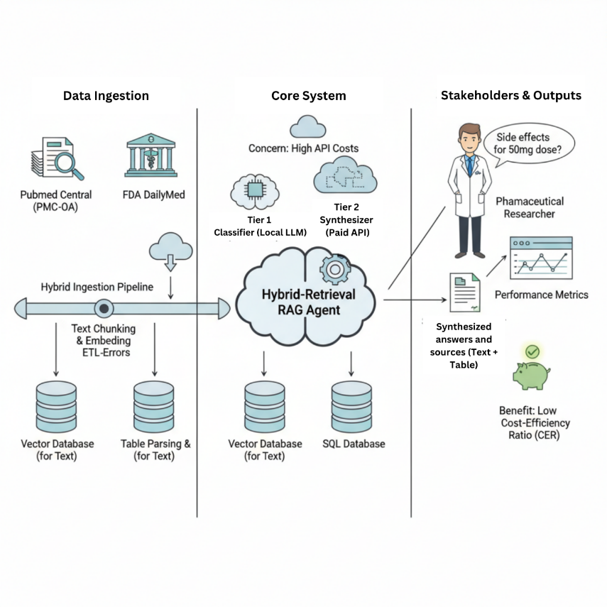
Figure 2: Rich Picture Diagram

4.3 Stakeholder Analysis
Stakeholder analysis is a crucial process for identifying all parties. It includes who will interact with, will be affected by, or have an interest in the Hybrid-Retrieval RAG Agent. Understanding their diverse needs and expectations is essential for defining the system's requirements.

4.3.1 Stakeholder Onion Model
The following model categorizes stakeholders into four primary layers:

4.3.2 Stakeholder List and Viewpoints
- The System (Core):
  - Hybrid-Retrieval RAG Agent: The software product itself, including both the databases (Vector DB, SQL DB) and the model cascade orchestrator.
- Users (Directly Interact):
  - Pharmaceutical Researcher / Scientist: (Primary User)
    - Viewpoint: "I need fast, accurate, and traceable answers. I must be able to trust the information, especially when it comes from a table. The system must be able to understand my complex, domain-specific questions."
  - Data Scientist:
    - Viewpoint: "I need to be able to evaluate the system's accuracy. I need to understand its performance metrics (CER, F1-score) and potentially refine its models."
- Business (Internal Stakeholders):
  - R&D Management / Project Sponsor:
    - Viewpoint: "This system must provide a clear return on investment. It needs to reduce API costs (justifying the CER) and demonstrably accelerate our research and drug discovery timelines."
  - System Developer (Student):
    - Viewpoint: "I need to successfully build and test a novel, functional prototype that meets all the academic and technical objectives defined in the proposal."
- The Environment (External Stakeholders):
  - Pharmaceutical Companies (Wider Industry):
    - Viewpoint: "We are interested in any new, validated architecture that can reduce our massive R&D data processing costs and improve accuracy."
  - Data Providers (e.g., PubMed, FDA):
    - Viewpoint: "Our data must be used in accordance with our access policies, and its limitations must be understood."

4.4 Elicitation Techniques
To define the system's functional and non-functional requirements, the following elicitation approach will be used:
- 1. Literature Review:
  - Description: An in-depth review of existing research (as detailed in Chapter 2) was conducted to identify already established problems, a baseline for system features, and important evaluation metrics (like RAGAs, CER, and F1-score) used in the academic community.
- 2. Stakeholder Interview:
  - Description: A semi-structured interview will be conducted with a Data Analyst who has experience in the business intelligence or data science field.
  - Justification: This interview is critical for gathering a real-world perspective on the problem. It will help to:
    - Validate the project's core assumptions.
    - Understand how a technical user would actually query a complex system (text vs. SQL).
    - Define the practical requirements for answer traceability, accuracy, and performance (latency).
- 3. Archival Research:
  - Description: A direct study of the primary data sources (PubMed Central and DailyMed) was done.
  - Justification: This technical investigation was necessary to define the requirements of the ingestion pipeline (e.g., handling inconsistent table structures, parsing XML) and to confirm the need of a hybrid (SQL + Vector) storage solution.

4.5 Discussion of Findings

4.5.1 Literature Review Findings
Finding 1: Standard RAG systems are "unimodal" (text-only) and fail when they encounter structured data, a problem known as "Lost-in-Vectorization."
- Conclusion: Naively vectorizing tables destroys their row-column integrity, leading to garbled context and factually incorrect answers. This confirms that a separate, specialized handling for tables (like a SQL database) is required.
- Citation: (Manjee, 2024); (Herzig et al., 2020)
Finding 2: Current research is siloed. Text-to-SQL frameworks focus only on relational data, while RAG systems focus only on unstructured text.
- Conclusion: There is a distinct lack of unified systems that can orchestrate a single query across both structured (SQL) and unstructured (Vector) databases to answer a "hybrid" question.
- Citation: (Liu et al., 2023); (Hao et al., 2024)
Finding 3: Most RAG architectures ignore operational cost, relying on a single, expensive LLM API for all tasks.
- Conclusion: This "single-model" approach is financially unviable at scale. LLM Cascades are a proven, state-of-the-art method for cost-optimization, but they have not been integrated with hybrid-retrieval systems.
- Citation: (Yue et al., 2023); (Rodriguez et al., 2023)

4.5.2 Interviews Findings
Codes | Themes | Conclusion
"Manual data joining"  "Split data sources"  "Text and database lookup" | Data Fragmentation | A primary user pain point is the manual effort required to link unstructured text (reports) with structured data (tables). This validates the need for a hybrid-retrieval system.
"Source citation"  "Need for verification"  "Don't trust 'black box'" | Answer Traceability | For an answer to be trusted, it must be 100% traceable. The system Must provide source links to the exact text chunk and table row used.
"Accuracy over speed"  "Cost of bad decisions"  "100% correct"  "Wrong answer is dangerous" | Primacy of Accuracy | Users strongly prefer a slower, perfectly accurate answer over a fast, 'mostly correct' one. This prioritizes retrieval/generation quality over latency.
"API cost scrutiny"  "Budget approval"  "Cost-saving as feature"  "Justifying expense" | Cost-Efficiency as a Core Requirement | Cost-quantification (the CER) is a critical adoption feature, not just a bonus. The model cascade is a key business justification.
"Silent query failure"  "Plausible but wrong"  "Missed a row" | Structured Data Integrity | Users fear "plausible but wrong" answers from tables. This validates that using precise SQL retrieval instead of "lossy" vector summarization of tables.
Table 8: Interview Findings

4.7 Context Diagram
The Context Diagram (also known as a Level 0 Data Flow Diagram) depicts the high-level boundary of the Hybrid-Retrieval RAG Agent. It models the system as a singular and central process and identifies all external entities (such as users, other systems, and data stores) that interact with the system. The diagram shows the key data flows (inputs and outputs) between the system and these external entities. It provides a clear, formal overview of the system's scope and its interactions.
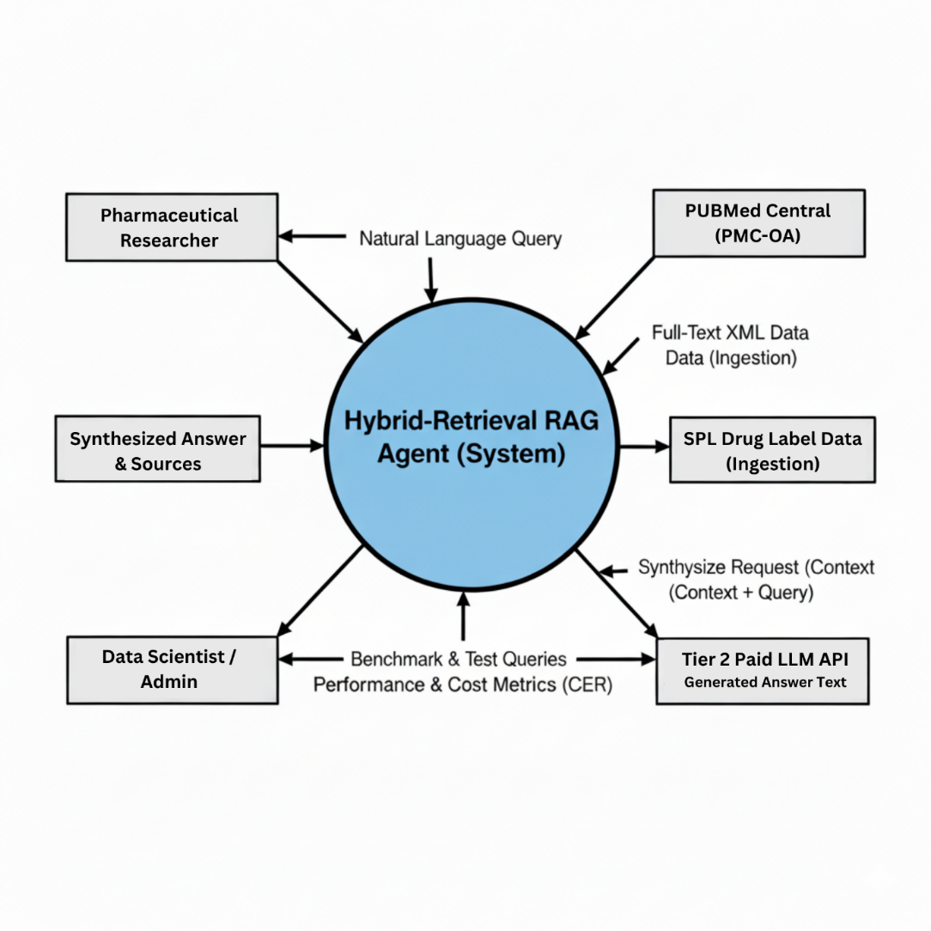
Figure 3: Context Diagram

4.8 Use Case Diagram
The Use Case Diagram illustrates the system's functionalities (use cases) and how external actors interact with them, defining the functional requirements of the Hybrid-Retrieval RAG Agent.

4.8.1 Actors
- Pharmaceutical Researcher: Primary user looking for answers from the system.
- Data Scientist / Admin: Technical user responsible for system evaluation and performance monitoring.
- <<Secondary>> Tier-2 Paid LLM API: External LLM service called for complex answer synthesis.

4.8.2 Use Cases
- Query System with Natural Language: Main function for Pharmaceutical Researcher to submit their questions.
  - <<includes>> Classify Query (Tier-1): Local LLM categorizes query intention.
  - <<includes>> Retrieve Hybrid Context: System fetches data from Vector DB and/or SQL DB.
- Synthesize with Tier-2 API: <<extends>> Query System with Natural Language for complex queries gets escalated to the external LLM.
- Manage & Evaluate System: For Data Scientist / Admin to test and monitor system performance.
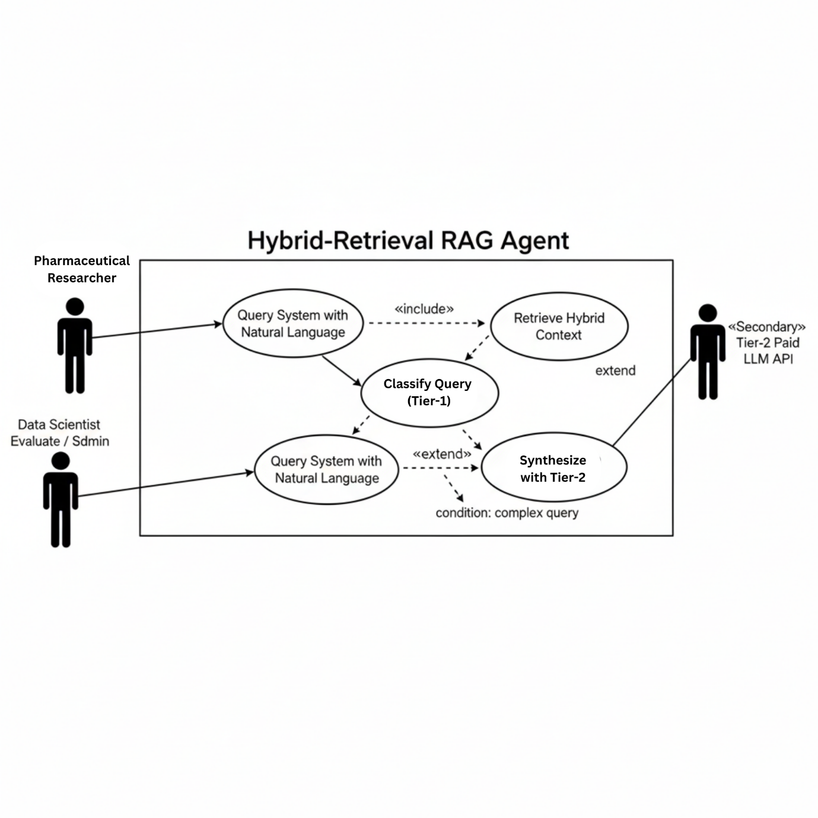
Figure 4: Use Case Diagram

4.9 Use Case Descriptions
This section provides a description of the primary use cases identified in the Use Case Diagram.
Use Case ID: UC-001
Use Case Name: Query System with Natural Language
Primary Actor: Pharmaceutical Researcher
Secondary Actor: Tier-2 Paid LLM API
Priority: High
Description: This use case describes the main function of the system. The researcher submits a query in plain English. The system then orchestrates the full hybrid-retrieval and model cascade pipeline to return a synthesized, and cost-effective answer.
Main Flow (Successful Scenario):
- The Pharmaceutical Researcher submits a natural language query via the system interface.
- The system receives the query and passes it to the Tier-1 (local) LLM for classification.
- The Tier-1 LLM classifies the query intent (e.g., "text-only," "sql-only," or "hybrid").
- The system orchestrator executes the retrieval plan:
  - If "text-only," it performs a semantic search on the Vector Database.
  - If "sql-only," it uses the Text-to-SQL tool on the SQL Database.
  - If "hybrid," it performs both retrievals in parallel.
- The system gathers the retrieved context(s).
- The system identifies that the query is complex enough to require escalation to the paid API (based on the classifier's decision).
- [Extension Point] The query is escalated to the Tier-2 Paid LLM API. The system sends the original query and all retrieved context.
- The Tier-2 Paid LLM API synthesizes the context and gives out a final answer.
- The system receives the answer from the API.
- The system presents the unified synthesized answer and its sources (e.g., text snippets, table references) to the Pharmaceutical Researcher.
Alternative Flows:
- 6a. (Simple Query): The Tier-1 classifier determines the query is simple and can be answered by the local LLM. The system skips escalation to the Tier-2 API, synthesizes the answer locally, and proceeds to step 10.
Post-conditions:
- The researcher's query is answered.
- The cost and latency of the query are logged for evaluation.

Use Case ID: UC-002
Use Case Name: Manage & Evaluate System
Primary Actor: Data Scientist / Admin
Priority: Medium
Description: This use case describes the "backend" function for a technical person to test metrics such as system's performance and accuracy..
Main Flow (Successful Scenario):
- The Data Scientist / Admin accesses the system's evaluation interface or scripts.
- The Data Scientist / Admin submits a batch of test queries (the Ground-Truth Evaluation Set).
- The system runs each test query through the full UC-001 pipeline.
- The system logs the performance for each query:
  - The generated answer.
  - The retrieved context.
  - The total API cost incurred.
  - The end-to-end latency.
- The Data Scientist / Admin runs an evaluation script to compare the generated answers against the ground-truth answers, calculating the F1-score and Faithfulness.
- The Data Scientist / Admin runs a script to aggregate all logged costs and calculates the final Cost-Efficiency Ratio (CER).
- The system provides all metrics (F1, CER, Latency) to the Data Scientist / Admin for analysis.

Post-conditions:
- The system's performance is quantitatively benchmarked.
- The Data Scientist / Admin has the metrics needed for the project's final evaluation.

4.10 Functional & Non-functional Requirements
This section defines the functional ("what it does") and non-functional ("how well it does it") requirements for the prototype. They are categorized using the MoSCoW method (Must Have, Should Have, Could Have, Won't Have).

4.10.1 Functional Requirements
ID | Requirement Description | Priority (MoSCoW)
FR01 | The system must ingest and process unstructured text into a Vector Database. | Must Have
FR02 | The system must ingest and process structured tables into a SQL Database. | Must Have
FR03 | The system must accept a natural language query from the user. | Must Have
FR04 | The system must use the Tier-1 (local) LLM to classify the query's intent (text, sql, hybrid). | Must Have
FR05 | The system must retrieve context from the Vector DB for text/hybrid queries. | Must Have
FR06 | The system must retrieve context from the SQL DB for sql/hybrid queries. | Must Have
FR07 | The system must synthesize a final answer using the Tier-2 (paid) LLM for complex queries. | Must Have
FR08 | The system should provide source references for the retrieved context. | Should Have
FR09 | The system monitor the API cost and latency for each query to calculate the CER. | Should Have
FR10 | The system could provide a basic web-based UI for submitting queries. | Could Have
FR11 | The system won’t have user authentication or multi-user accounts in this prototype. | Won't Have
Table 9: Functional Requirements

4.10.2 Non-functional Requirements
ID | Requirement Description | Priority (MoSCoW)
NFR01 | Accuracy (Faithfulness): The system must generate answers that are factually supported in the retrieved context (Vector DB or SQL DB). | Must Have
NFR02 | Cost-Efficiency: The system must demonstrate a measurably lower Cost-Efficiency Ratio (CER) than the vector-only baseline. | Must Have
NFR03 | Performance (Latency): The system should return a synthesized answer for a hybrid query within 15 seconds. | Should Have
NFR04 | Scalability (Ingestion): The ingestion pipeline should be able to process at least 1,000 documents. | Should Have
NFR05 | Usability: The system could have an intuitive interface that clearly differentiates the query input from the output answer. | Could Have
NFR06 | Availability: The system won’t have 24/7 high-availability or real-time fault tolerance. | Won't Have
Table 10: Non-functional Requirements

4.11 Chapter Summary
This chapter detailed the Software Requirement Specification (SRS) for the Hybrid-Retrieval RAG Agent.
It began with the Rich Picture Diagram and Stakeholder Analysis, illustrating the system's environment and key actors. The Elicitation Techniques, including a stakeholder interview, were outlined. The Context Diagram formally defined the system boundary, while the Use Case Diagram and Descriptions mapped out its primary functionalities, including the conditional use of the Tier-2 LLM. Finally, the Functional and Non-functional Requirements were specified and prioritized (MoSCoW), emphasizing accuracy, cost-efficiency, and hybrid data processing as core objectives.

Chapter 5: Social, Legal, Ethical and Professional Issues (SLEP)

5.1 Chapter Overview
This chapter examines the Social, Legal, Ethical, and Professional (SLEP) issues involved in building a RAG-based pharmaceutical agent. Because this system pulls and summarizes medical data, it has to operate within strict regulatory and ethical limits. Using Large Language Models (LLMs) with drug databases raises concerns about data privacy, clear logic, and legal rights to information. I have identified the main SLEP risks for this project and included specific ways to handle them, ensuring the agent is safe for professional use.

5.2 SLEP Issues and Mitigation
Category & Issue | Description | Mitigation Strategy
SOCIAL
Access Inequality | High API costs may exclude resource-constrained researchers and institutions in developing countries, creating a two-tier system where well-funded entities accelerate drug discovery while others fall behind, widening global health equity gaps. | Implement tiered pricing with free tier for academic/non-profit researchers. Open-source core architecture to enable self-hosting. Partner with global health organizations to subsidize access for underserved populations.
Professional Displacement | Automation may threaten roles of pharmaceutical information specialists and medical librarians who provide critical literature review and evidence synthesis services. | Position as augmentation tool requiring expert oversight. Design features for professional validation and annotation. Provide training programs for AI-augmented researcher roles.
Over-Reliance | Users may uncritically accept AI-generated responses as definitive answers in high-stakes pharmaceutical contexts where errors could have serious consequences, particularly given LLM hallucination risks. | Display confidence scores with explicit warnings. Provide prominent source citations with verification links. Include disclaimers emphasizing informational purpose only. Implement query logging and usage audits.
LEGAL
Data Privacy (GDPR/HIPAA) | Processing pharmaceutical data through third-party LLM APIs raises concerns about data sovereignty, cross-border transfers, and compliance with GDPR/HIPAA. Queries may contain proprietary drug formulations or confidential research data. | Use encrypted transmission (TLS 1.3+). Select LLM providers with GDPR/HIPAA-compliant DPAs. Support self-hosted deployment option. Implement data classification and sensitive content detection. Encrypt logs at rest with RBAC and 90-day retention.
Intellectual Property | Retrieving and synthesizing copyrighted pharmaceutical literature raises questions about fair use, derivative works, and licensing. Vector embeddings and synthesized responses may violate copyright or licensing terms. | Only ingest content with explicit permission or text mining licenses. Implement access controls mirroring source licensing. Provide proper attribution in all responses. Prevent document reconstruction. Clear terms of service on fair use boundaries.
Liability | If the system provides incorrect information leading to patient harm, regulatory violations, or drug development errors, questions arise about who is legally responsible: developers, LLM providers, pharmaceutical companies, or end users. | Explicit disclaimers in terms of service ('as-is', informational only). Validation testing against benchmarks. Red-team testing for dangerous misinformation. Route high-risk queries to more capable models. Maintain audit logs. Professional liability insurance. Position as decision support, not autonomous decision-maker.
ETHICAL
Algorithmic Bias | Training data biases may manifest as geographic bias (Western research prioritized), publication bias (positive findings over-represented), language bias (non-English excluded), or commercial bias (industry-funded studies favored). | Diversify sources including international databases, negative results journals, and multilingual content. Implement diversity-promoting ranking factors. Regular bias auditing with test queries. Display source distribution to users. Ethics advisory board for ongoing oversight.
Transparency | Complex AI components operate as 'black boxes.' Users receive synthesized answers without understanding how conclusions were reached, which sources were prioritized, or what limitations exist, undermining scientific reproducibility. | Implement explainability dashboard showing: model routing decisions, retrieval strategies used, similarity scores, generated SQL queries, source rankings, conflicting information handling. Granular citation annotation. Chain-of-thought reasoning display. Support query replay with different settings.
Dual-Use Risk | System could be misused for bioweapon development, illegal drug synthesis, pharmaceutical counterfeiting, regulatory evasion, or enabling dangerous self-medication by non-experts accessing complex pharmaceutical information. | Content filtering for dangerous queries using keyword and semantic analysis. User authentication with tiered access based on credentials. Rate limiting and anomalous usage detection. Comprehensive audit logs with security team review. Collaboration with regulatory/law enforcement. Controlled release of high-risk components.
PROFESSIONAL
Standards Compliance | Development must adhere to professional standards from ACM, IEEE, healthcare technology organizations (AMIA, HIMSS), and AI ethics frameworks (EU AI Act, WHO AI in health guidelines). Requires documented processes enabling peer review. | Follow software engineering best practices (Git, code review, CI/CD, comprehensive testing). Engage in professional development (conferences, training). Multi-disciplinary advisory board. Professional ethics training for team. Transparent documentation of capabilities and limitations.
Environmental Impact | Large-scale LLM usage requires massive computational power with significant carbon footprint. Single GPT-4 query equivalent to driving several miles. Creates tension between environmental responsibility and pharmaceutical research acceleration. | Optimize model cascade for energy efficiency with carbon intensity consideration. Aggressive caching of common queries. Energy-efficient vector database configuration. Batch processing during low-demand periods. Carbon footprint tracking dashboard. Partner with carbon-neutral LLM providers. Purchase carbon offsets.

5.3 Chapter Summary
This chapter has analyzed the Social, Legal, Ethical, and Professional (SLEP) issues involved in building a responsible AI for pharmaceutical research. Ten main problems were found across these four areas, including social concerns like AI over-reliance, legal hurdles regarding data privacy and IP, ethical risks like bias, and professional duties like environmental impact.
To handle these, specific mitigation strategies are to be built into the system. These include technical fixes like encryption and bias auditing, as well as operational steps like transparent documentation and clear terms of service. By addressing these SLEP issues early, the goal is to make sure the RAG agent isn't just fast and cheap, but also legally compliant and ethically safe.
These strategies show that building good healthcare AI requires looking at both the code and its impact on society. The next chapter will cover the system design, explaining how these safety measures are actually integrated into the technical architecture.

Chapter 6: Design

6.1 Chapter Overview
This chapter covers the design of the Pharmaceutical RAG Agent (Pharmask) and how it meets both technical and user-focused goals. The design connects the initial requirements like hybrid retrieval and cost-efficient LLM usage to the actual pipeline, which uses a two-tier approach: Tier-1 for query sorting and dual-retrieval (Vector and SQL), and Tier-2 for generating the final answer.
The chapter is organized to show how these goals are met. Section 6.2 covers design goals like performance and accuracy, while Section 6.3 gives a high-level look at the system architecture and how data flows through it. Section 6.4 breaks down the detailed design using an object-oriented approach to show how different components interact. In Section 6.5, I explain the AI and ML design for classification and synthesis, followed by Section 6.6, which discusses the UI and accessibility choices. Finally, Section 6.7 summarizes how these design decisions help the system reach its overall goals.

6.2 Design Goals
This section outlines the design goals for Pharmask, focusing on how the system meets its non-functional requirements. Each goal is directly tied to the current architecture and implementation.

Performance
The system aims to finish a full query classification, retrieval, and synthesis in under 15 seconds. To hit this target, I used a fast Tier-1 model (Llama 3.1 8B on Groq) for quick classification and SQL generation. I also capped the results, limiting vector search to the top 5 matches and SQL to 20 rows. The orchestrator handles the sequence of tasks, and the final latency is tracked and returned to the user through the API.

Usability
The design focuses on a simple, "no-training" interface. It features a single query box and clearly displays the answer along with the classification details, source citations, and costs. The implementation includes a loading spinner and a structured layout in the frontend to make the AI’s reasoning and sources easy to read.

Accuracy
Accuracy is handled at three distinct stages:
- Classification: A structured prompt ensures the Tier-1 model correctly routes queries to the right retrieval method (Vector, SQL, or Hybrid).
- Retrieval: I used semantic embeddings for vector search and a read-only LLM-generated SQL process for structured data.
- Faithfulness: The synthesis prompt strictly instructs the model to only use the provided context and cite its sources.

Scalability
The design is built to grow with more data or higher traffic. The ingestion process is batch-oriented, allowing more documents to be added to ChromaDB and SQLite easily. Because the application is stateless and uses external APIs for the LLMs, the FastAPI layer can be scaled horizontally. Most settings, like which model or provider to use, are centralized in a config file for easy updates.

Security
For this prototype, security focuses on safe data handling. While there is no full user authentication yet, the SQL retriever is strictly limited to "SELECT" statements to prevent database tampering. Additionally, sensitive information like API keys is never hardcoded; they are managed through environment variables to keep them out of the source code.
.

6.3 System Architecture Diagram
The architecture of Pharmask follows a tiered approach to separate the user interface, logic, and data storage. This structure ensures that each part of the system has a specific role, making the overall pipeline easier to manage and scale.

Architecture Tiers
- Presentation Layer: This is the entry point for the user, consisting of a simple web interface. It communicates with the backend using standard HTTP requests to submit queries, trigger data ingestion, or check the system's health.
- API Layer: Built with FastAPI, this layer acts as the gatekeeper. It manages the web endpoints and tracks performance metrics like latency, but it doesn't handle the core logic; instead, it passes requests down to the orchestrator.
- Orchestration Layer: The ‘RAGOrchestrator’ is the "brain" of the operation. It coordinates the entire workflow by calling the classifier, triggering the correct retrievers (Vector, SQL, or both), and finally sending the gathered info to the synthesizer to generate an answer.
- Service Layer: This layer contains the specialized tools that do the heavy lifting:
  - QueryClassifier (Tier-1): Uses a fast LLM to decide if a question needs a text search, a database lookup, or both.
  - HybridRetriever: Manages the ‘VectorRetriever’ (for semantic text search in ChromaDB) and the ‘SQLRetriever’ (for structured data in SQLite) and merges the results.
  - AnswerSynthesizer (Tier-2): Uses a more powerful LLM to combine the retrieved data into a final, cited response.
- Data Layer: This is where the information lives. We use ChromaDB for storing document embeddings and SQLite for structured drug data like dosages and interactions.

Ingestion Pipeline
To get data into the system, an offline ingestion pipeline handles the prep work. The ‘IngestionWorker’ reads files (XML, PDF, or JSON), breaks them into manageable chunks, and loads them into their respective databases. This allows the system to be updated with new pharmaceutical research without interfering with active user queries
.
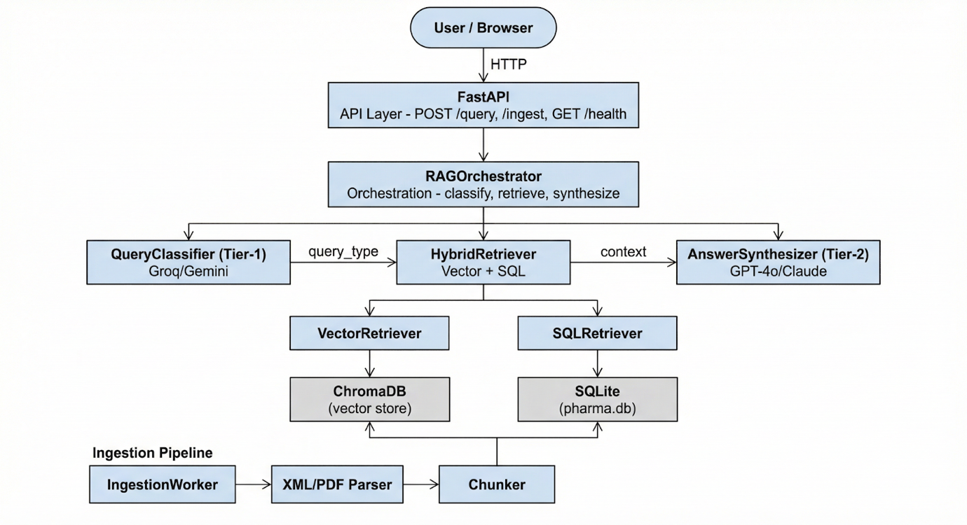

6.4 Detailed Design
The detailed design follows an object-oriented approach. The purpose of each diagram is stated; the descriptions are based on the actual implementation.
Class diagram (main components)
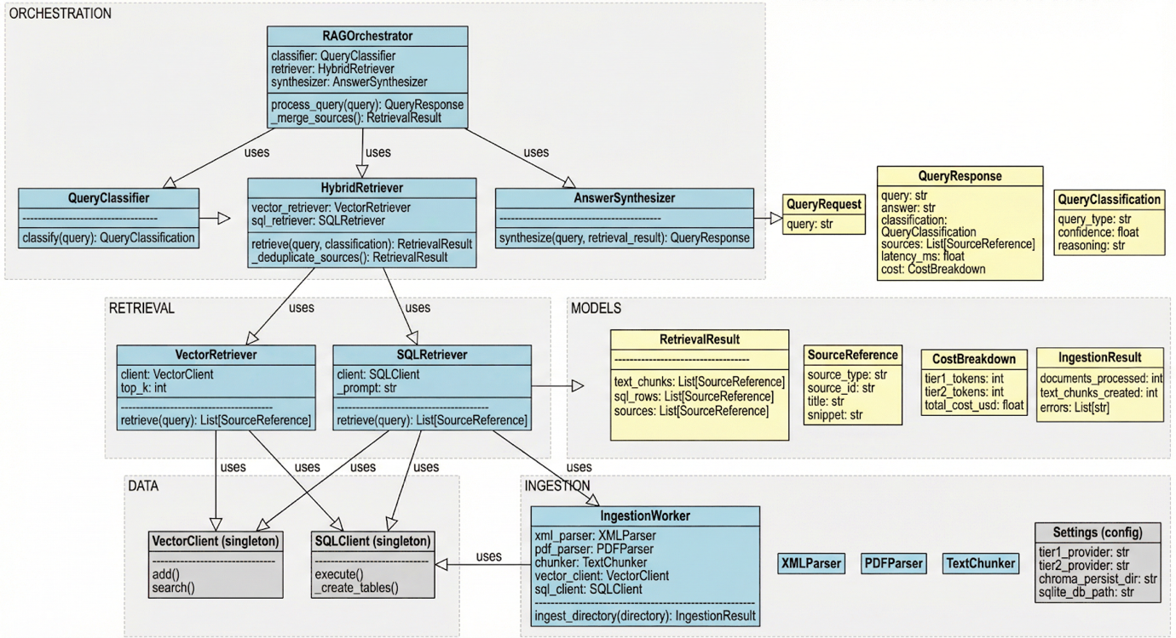
Purpose: Show the main types and their dependencies.
Key classes:
- RAGOrchestrator: Holds references to QueryClassifier, HybridRetriever, AnswerSynthesizer; has process_query(query) -> QueryResponse and _merge_sources(retrieval_sources, synthesis_sources).
- QueryClassifier: Uses ChatPromptTemplate (classification prompt), JsonOutputParser, and a Tier-1 BaseChatModel; method classify(query) -> (QueryClassification, tokens).
- HybridRetriever: Holds VectorRetriever and SQLRetriever; method retrieve(query, classification) -> (RetrievalResult, tokens); branches on classification.query_type (text → vector only; sql → SQL only; hybrid → both).
- VectorRetriever: Uses VectorClient and settings.vector_top_k; method retrieve(query, filter_metadata?) -> dict (chunks, sources).
- SQLRetriever: Uses SQLClient, Tier-1 LLM, and a SQL generation prompt; method retrieve(query) -> (dict, tokens) (rows, sources).
- AnswerSynthesizer: Uses Tier-2 LLM and synthesis prompt; method synthesize(query, retrieval_result) -> (answer, sources, tokens).
- IngestionWorker: Uses XMLParser, PDFParser, JSONParser, TextChunker, VectorClient, SQLClient; method ingest_directory(directory) -> IngestionResult.

6.5 Algorithm Design
The core intelligence of Pharmask relies on three main processes: query classification, answer synthesis, and SQL generation. Each step uses specific prompts and models to ensure the system is both accurate and cost-effective.

1. Query Classification (Tier-1)
The goal of classification is to decide whether a user’s question needs a text search (Vector), a database lookup (SQL), or both (Hybrid).
To do this, the system inserts the user's query into a fixed prompt that defines these categories and provides examples. We use a fast Tier-1 model like Llama 3.1 8B with a "temperature" of 0 to keep the output consistent. The model outputs a JSON object containing the determined type, a confidence score, and the reasoning behind the choice. This result is then validated and passed to the next stage of the pipeline while we track the token count to monitor costs.
Pseudocode:
FUNCTION classify(query: string) -> (QueryClassification, token_count):
prompt = CLASSIFICATION_PROMPT.format(query=query)
raw_output = Tier1_LLM.invoke(prompt)
parsed = JSON.parse(raw_output) // query_type, confidence, reasoning
RETURN (QueryClassification(parsed), tokens_used)

2. Answer Synthesis (Tier-2)
Once the data is retrieved, the synthesis step turns raw text chunks and database rows into a readable answer.
The system formats the retrieved information into clear text and SQL blocks and inserts them into a synthesis prompt. This prompt strictly instructs the LLM to only use the provided context, cite its sources using a specific format (e.g., [Source: id]), and remain precise with medical data. We use a more powerful Tier-2 model, such as GPT-4o, with a low temperature (0.2) to ensure the answer is factual and grounded in the data. The final output includes the answer string and a list of all referenced sources.
Pseudocode:
FUNCTION synthesize(query, retrieval_result) -> (answer, sources, token_count):
text_context = format(retrieval_result.text_chunks)
sql_context = format(retrieval_result.sql_rows)
prompt = SYNTHESIS_PROMPT.format(query=query, text_context=text_context, sql_context=sql_context)
answer = Tier2_LLM.invoke(prompt)
sources = retrieval_result.sources // plus any from synthesis
RETURN (answer, sources, tokens_used)

3. SQL Generation (Tier-1)
For structured questionslike asking for a specific drug dosage, the SQLRetriever uses the Tier-1 LLM to generate a database query.
The LLM is given a prompt that describes our database schema (tables like drugs and dosages) and a set of strict rules: the query must be read-only (SELECT only), limited to 20 rows, and must include source document IDs. The system then validates the generated SQL to ensure it doesn't contain any dangerous commands before executing it against the SQLite database and mapping the results back to their sources.

6.6 UI Design
The interface for Pharmask is designed as a single, scrollable page to keep the user focused on the core task: asking a question and getting a verified answer. By avoiding multiple screens or complex navigation, the design reduces the "cognitive load" on the user.

Interface Layout
The page starts with a clear title and subtitle describing the system’s hybrid nature. Below this sits a single, large text input where the user types their pharmaceutical query. Once they hit "Search," a loading spinner appears to show the system is working. The results are then displayed in four distinct sections:
- Answer: The generated response in plain paragraph form.
- Classification: A breakdown of how the AI categorized the query (type, confidence, and reasoning).
- Sources: A list of the specific documents or database rows used, including IDs and snippets.
- Metadata: A summary of the performance, showing token counts, total cost, and latency in milliseconds.

Design Decisions
- Usability: By grouping the answer and the "why" (classification and sources) together, the user can immediately judge if the information is trustworthy. Showing the AI’s reasoning and cost also helps with transparency and debugging during the prototype phase. The layout is responsive, meaning it adjusts automatically to work on different screen sizes.
- Accessibility: I used a semantic HTML structure like headers, forms, and sections to make the page easier for screen readers to navigate. The input box has a clear focus style so users know exactly where they are typing, and the color palette was chosen to ensure high contrast for better readability.
The final implementation in app/templates/index.html follows this design exactly, using CSS variables for consistent styling and a simple JavaScript-driven loading state to manage the user experience.

6.7 Chapter Summary
This chapter outlined the complete design for the Pharmask RAG Agent, linking our original goals, performance, usability, accuracy, scalability, and security to the actual system components. By breaking the system into clear layers (Presentation, API, Orchestration, Service, and Data), we’ve created a structure that handles everything from the initial user query to the final cited answer.
The design relies on a specific data flow: the user sends a query through the FastAPI layer, the RAGOrchestrator manages the logic, and specialized services handle classification and retrieval. We used an object-oriented approach to define the responsibilities of key classes like the QueryClassifier and HybridRetriever, ensuring the code is modular and easy to maintain.
The core "intelligence" of the system is driven by three LLM-based algorithms:
- Tier-1 Classification to route queries correctly.
- Tier-2 Synthesis to create grounded, cited answers.
- SQL Generation to pull structured data safely.
Finally, the UI design focuses on a clean, single-page layout that prioritizes transparency by showing the user exactly how the AI reached its conclusion, including source citations and cost metrics. This design provides a solid foundation for the implementation and evaluation phases, ensuring that the final product is not just technically functional, but also cost-efficient and easy to us.

Chapter 7: Implementation

7.1 Chapter Overview
This chapter describes how the Pharmask design was translated into a working system. The implementation phase takes the architecture, classes, and algorithms from the previous chapter and turns them into actual code, deployable services, and a functional interface.
The chapter begins by justifying the technology stack (Section 7.2), covering the choice of programming language, frameworks, and libraries. Section 7.3 details the development of core features like the query pipeline, data ingestion, and retrieval modules, explaining how these different pieces are integrated. Section 7.4 focuses on the user interface and how it communicates with the backend. In Section 7.5, the technical challenges faced during coding and the solutions used to fix them are discussed. Finally, Section 7.6 summarizes the implementation and confirms the system is ready for testing.

7.2 Technology Selection
Technology choices were driven by the need for async API handling, multiple LLM providers, vector and relational storage, document parsing, and a simple web UI while keeping the stack maintainable and aligned with the two-tier RAG design.

7.2.1 Technology Stack
The overall stack is organised as follows:
Layer | Technology | Role
Runtime | Python 3.x | Application and scripts
Web / API | FastAPI, Uvicorn | REST API and HTTP server
LLM orchestration | LangChain (core, OpenAI, Anthropic, Google Genai, Groq) | Prompts, chains, multi-provider LLMs
Vector store | ChromaDB | Embeddings and semantic search
Relational store | SQLite + SQLAlchemy | Structured pharmaceutical tables
Embeddings | sentence-transformers | Local embedding model for ChromaDB
Document processing | lxml, pypdf, pdfplumber | XML, PDF parsing
Validation / config | Pydantic, pydantic-settings | Schemas and environment-based config
Frontend | HTML, CSS, vanilla JavaScript | Single-page query UI
Testing | pytest, pytest-asyncio | Unit and async tests
Evaluation | rank-bm25, scikit-learn | Baselines and metrics
Data | datasets, huggingface-hub | PMC-OA dataset download

Programming Languages
Python: The project is implemented entirely in Python. Python was chosen for:
- Strong support for async I/O (asyncio), required for non-blocking LLM and retrieval calls
- Mature ecosystems for ML and LLM integration (LangChain, sentence-transformers)
- Fast prototyping and readability for research-oriented code
- Wide support for ChromaDB, SQLAlchemy, and FastAPI. No other primary language was used for the backend or services.

7.2.3 Development Framework
FastAPI: FastAPI was selected as the web and API framework because it is async-native, which aligns with the async query pipeline (classify → retrieve → synthesize). It provides automatic OpenAPI documentation, request/response validation via Pydantic, and minimal boilerplate. The application entry point is app/main.py, which defines the FastAPI app, mounts templates, and registers routes for /, /health, POST /query, and POST /ingest. Uvicorn is used as the ASGI server (e.g. uvicorn app.main:app --reload --port 8000), supporting hot reload during development.

7.2.4 Libraries / Toolkits
Key libraries and their purpose in the implementation:
Library | Purpose
langchain-core, langchain-openai, langchain-anthropic, langchain-google-genai, langchain-groq | Prompt templates (ChatPromptTemplate), LLM wrappers for Tier-1 (Groq/Gemini/OpenAI) and Tier-2 (OpenAI/Anthropic), and output parsing (e.g. JsonOutputParser for classification).
chromadb | Persistent vector store for document chunks; used by VectorClient for add/search with configurable top_k.
sqlalchemy | SQLite engine, session management, and DDL for tables (drugs, indications, dosages, adverse_reactions, interactions) in SQLClient.
sentence-transformers | Local embedding model for encoding queries and documents before storage and search in ChromaDB.
lxml | Parsing PMC-OA and DailyMed XML in XMLParser.
pypdf, pdfplumber | PDF text and table extraction in PDFParser.
pydantic, pydantic-settings | Request/response models (QueryRequest, QueryResponse, QueryClassification, etc.) and configuration (Settings) loaded from .env.
httpx | Used by LangChain for HTTP calls to LLM APIs.
python-dotenv | Loading .env for API keys and paths.
jinja2 | Server-side rendering of the single HTML template (index.html) for the root route.
datasets, huggingface-hub | Downloading PMC-OA dataset (e.g. via scripts/download_pmc_dataset.py).
rank-bm25, scikit-learn | BM25 baseline and metrics in the evaluation package.
pytest, pytest-asyncio | Unit tests (e.g. classifier tests in tests/test_classifier.py) and async test support.

7.2.5 Integrated Development Environments (IDEs)
The development process used standard tools to keep the project clean and easy to run. I used Visual Studio Code (VS Code) as the primary IDE, taking advantage of its Python extensions for debugging, linting, and running tests. These tools make it much easier to manage virtual environments and the ‘requirements.txt file’, ensuring all dependencies stay organized.
A key focus was keeping the project "IDE-independent." This means you don't need a specific proprietary setup to get it working; the entire system can be launched directly from the terminal using a simple command like ‘uvicorn app.main:app –reload’. This makes the code more portable and easier for other developers to test or deploy without needing to reconfigure their own local environments.

7.2.6 Summary of Technology Selection
The chosen stack fits the system because:
- FastAPI + Python enable an async, validated API that matches the pipeline’s I/O-bound nature;
- LangChain abstracts multiple LLM providers and keeps prompt/chain logic consistent across Tier-1 and Tier-2
- ChromaDB and SQLite provide lightweight, file-based persistence for vectors and tables without operational overhead
- Pydantic ensures type-safe contracts between API, orchestrator, and services
- Sentence-transformers allow offline embeddings for ChromaDB. Together, these choices support modular development, clear separation between orchestration and retrieval/synthesis, and straightforward testing and evaluation.

7.3 Core Functionalities Implementation

7.3.1 Dataset Description and Splits (AI/ML)

Evaluation Dataset
The core of our testing is a JSON file located at ‘data/evaluation/pharma_qa_dataset.json’. Each entry in this file contains the question text, the expected query type (Text, SQL, or Hybrid), the correct source, and ground-truth keywords to check the answer's quality. The ‘pharma_evaluator.py’ script runs every question through the entire pipeline. It measures how well the system categorizes queries, whether it finds the right documents, and how much each request costs.

Ingestion Data
For the actual pharmaceutical knowledge base, the system pulls from XML, PDF, and JSON files stored in a specific directory. We primarily use the PMC-OA (PubMed Central Open Access) and DailyMed datasets. I’ve included scripts to download the PMC-OA subset directly from Hugging Face for easier setup.
The system is designed to be flexible; it doesn't require a fixed dataset size. It simply indexes whatever documents are added to the ingestion folder, making it easy to expand the agent's knowledge without rewriting any code.

7.3.2 Modular Development
The implementation is organised into clear modules:
● `app/main.py`: FastAPI app, route definitions, and latency measurement; no business logic beyond calling the orchestrator and ingestion worker.
● `app/config.py`: Settings (Pydantic BaseSettings) for Tier-1/Tier-2 providers and models, API keys, ChromaDB and SQLite paths, retrieval settings (e.g. vector_top_k, chunk_size, chunk_overlap).
● `app/models/schemas.py`: Pydantic models for API and pipeline: QueryRequest, QueryResponse, QueryClassification, SourceReference, RetrievalResult, CostBreakdown, IngestionResult.
● `app/db/`: VectorClient (ChromaDB singleton) and SQLClient (SQLite singleton with SQLAlchemy); used by retrieval and ingestion.
● `app/services/orchestrator.py`: RAGOrchestrator instantiates classifier, retriever, and synthesizer; implements process_query(query) and _merge_sources().
● `app/services/classifier/`: QueryClassifier Tier-1 prompt, LLM invocation, JSON parsing to QueryClassification.
● `app/services/retrieval/`: VectorRetriever, SQLRetriever, HybridRetriever vector search, SQL generation and execution, and routing by query_type.
● `app/services/synthesis/`: AnswerSynthesizer Tier-2 prompt, context formatting, and answer generation with source references.
● `app/services/ingestion/`: IngestionWorker, XMLParser, PDFParser, JSONParser, TextChunker file discovery, parsing, chunking, and loading into ChromaDB and SQLite.
● `app/services/cost_calculator.py`: Token-based cost calculation and CostBreakdown for Tier-1 vs Tier-2.
● `app/evaluation/`: PharmaEvaluator, dataset loading, metrics aggregation, and report generation; baselines (e.g. BM25, context-provided RAG) for comparison.

Each service is designed to be testable in isolation (e.g. classifier tests mock the LLM) and to depend on interfaces (e.g. retriever returns RetrievalResult) rather than concrete I/O details.

7.3.3 Code Structure
Directory layout:
app/
├── main.py # FastAPI app and routes
├── config.py # Settings
├── models/
│ └── schemas.py # Pydantic models
├── db/
│ ├── vector_client.py # ChromaDB client
│ └── sql_client.py # SQLite client
├── services/
│ ├── orchestrator.py
│ ├── cost_calculator.py
│ ├── classifier/
│ │ └── query_classifier.py
│ ├── retrieval/
│ │ ├── vector_retriever.py
│ │ ├── sql_retriever.py
│ │ └── hybrid_retriever.py
│ ├── synthesis/
│ │ └── answer_synthesizer.py
│ └── ingestion/
│ ├── worker.py
│ ├── xml_parser.py
│ ├── pdf_parser.py
│ ├── json_parser.py
│ └── chunker.py
├── evaluation/ # Pharma evaluator, baselines, metrics
└── templates/
└── index.html # Single-page UI
The orchestrator imports services at runtime (e.g. inside the route handler) to avoid circular imports. Configuration and schema types are shared via app.config.settings and app.models.

7.3.4 Module Integration
The implementation of Pharmask is centered around three primary operational paths: the query pipeline, the ingestion process, and the evaluation suite.

The Query Path
When a user sends a question via a ‘POST /query’ request, the API layer in ‘main.py’ starts a timer and hands the query to the ‘RAGOrchestrator’. The orchestrator then manages a four-step sequence: it classifies the query using the Tier-1 model, retrieves the relevant data from the vector or SQL databases, synthesizes a final answer using the Tier-2 model, and finally merges the sources while calculating the total API cost. Once finished, the system attaches the total latency in milliseconds and sends the full response back to the user.

The Ingestion Path
To add new medical data, the system uses the ‘POST /ingest’ endpoint. This triggers the ‘IngestionWorker’, which scans a specific directory for XML, PDF, or JSON files. The worker uses specialized parsers to turn these files into a ‘ParsedDocument’ format, breaks the text into smaller pieces using a ‘TextChunker’, and then saves those chunks into ChromaDB and SQLite. At the end of the process, it returns a report showing how many documents were successfully processed and if any errors occurred.

Evaluation
For testing, I developed a script (scripts/run_pharma_eval.py) that uses the same logic as the live query path. It loads the pharmaceutical QA dataset and runs each question through the ‘PharmaEvaluator’. This allows us to test the system's performance in a controlled way, measuring how accurate the classification is and how well the AI captures key medical terms. The final metrics are printed to the console and saved for analysis.

7.4 User Interface Implementation

7.4.1 Frontend Components
The user interface is a single HTML page (app/templates/index.html) with embedded CSS and JavaScript. It includes:
● Header: Title “Pharmaceutical RAG Agent” and subtitle describing the hybrid RAG system.
● Query form: A single text input (placeholder “Ask a pharmaceutical question…”) and an “Ask” submit button; the button shows a loading spinner and is disabled while a request is in progress.
● Response container: Initially hidden; shown when a response is received. It displays:
○ A classification badge (text / sql / hybrid) with colour coding.
○ Latency (e.g. “1234 ms”).
○ The synthesized answer in a readable block.
○ An optional cost panel: total cost, Tier-1 and Tier-2 cost and token counts, total tokens, latency, and savings vs Tier-2-only.
○ A sources section: list of source items with type (text/table), title/source_id, and snippet.
● Error message area: Shown when the API returns an error (e.g. 500 or validation error); displays the error detail.
● Example queries: Buttons for sample text, sql, and hybrid questions; clicking one fills the input and triggers submit.
● Footer: Short line describing the system (e.g. “Powered by Hybrid RAG with Tier-1 classification and Tier-2 synthesis”).
Styling uses CSS variables for colours (primary, background, surface, text, border, success, error) and responsive layout (max-width container, padding). Classification and source-type badges use distinct colours (e.g. blue for text, green for sql, amber for hybrid).

7.4.2 Backend Integration
The frontend implementation for Pharmask is kept simple and efficient by using the Fetch API to communicate directly with the backend. When a user submits a question, the browser sends a POST /query request containing the user's input as a JSON object. The system then waits for a ‘QueryResponse’ that includes the final answer, classification details, source citations, and performance metrics like cost and latency.
Once the data is received, a JavaScript function called ‘displayResponse(data)’ dynamically updates the page. It fills in the classification badge (showing if the query was Text, SQL, or Hybrid), calculates the latency, and lists out the sources. I also added a small formatting script to handle the cost display since many queries cost a fraction of a cent, it displays values like "< $0.0001" to keep the UI clean. If something goes wrong, a dedicated error area appears with the specific details from the server.
To keep things straightforward for deployment, the page is served by FastAPI using Jinja2 templates. This means the frontend and the API live on the same "origin" (the same host and port), which completely avoids the need for complex Cross-Origin Resource Sharing (CORS) configurations. It makes the prototype much easier to run locally or move to a server without hitting permission blocks.

7.4.3 Accessibility Considerations
The page uses semantic structure (header, form, sections) and a single main form with a labelled submit action. The query input uses a placeholder and can be given an explicit label or aria-label for screen readers. Focus styles are applied (e.g. border colour change on #query-input:focus) to support keyboard navigation. Button disabled state during loading prevents double submission and is visible (opacity change). Colour contrast follows a defined palette (e.g. primary blue on white, error red). Further improvements could include ARIA live regions for dynamic content (answer, errors) and a visible skip link if the page grows.

7.5 Challenges and Solutions

7.5.1 Debugging
● Challenge: Tracing errors across async calls (classifier → retriever → synthesizer) and multiple LLM providers.
● Solution: Structured logging (e.g. logger.info in orchestrator and services) records classification result, retrieval counts, and token/cost summary. Exceptions are caught at the route level and returned as HTTP 500 with a detail message. FastAPI’s automatic validation surfaces Pydantic errors for malformed requests. For local debugging, DEBUG=true and LOG_LEVEL=INFO (or DEBUG) in .env help; the orchestrator is imported inside the route to simplify stack traces and avoid circular import issues.

7.5.2 Performance Issues
● Challenge: Keeping end-to-end latency acceptable (e.g. target &lt;15 seconds) when calling Tier-1, then retrieval (vector + optional SQL with Tier-1 for SQL generation), then Tier-2.
● Solution: (1) Use a fast Tier-1 model (e.g. Groq Llama 3.1 8B) and limit retrieval size (vector_top_k, SQL row limit) to reduce payload and Tier-2 time. (2) Use async throughout so I/O-bound waits do not block the event loop. (3) Vector search is synchronous in the current implementation but runs in a thread-friendly way; SQL execution is fast for small result sets. (4) Latency is measured in main.py and returned in the response so it can be monitored and tuned.

7.5.3 Resource Constraints
● Challenge: Large document sets and embedding computation during ingestion; memory for sentence-transformers and ChromaDB.
● Solution: (1) Ingestion is batch and file-based; documents are processed sequentially so memory use stays bounded per file. (2) Chunk size and overlap are configurable (chunk_size, chunk_overlap in settings) to balance context quality and storage. (3) ChromaDB persistence is on disk (chroma_persist_dir); SQLite is file-based (sqlite_db_path). (4) Dataset download scripts support a --limit (e.g. 100 or 1000 articles) for smaller test corpora. (5) API keys and paths are in .env so different environments can point to different data directories or providers without code changes.

7.5.4 Additional Implementation Notes
● SQL safety: The SQL retriever prompt instructs the LLM to generate only read-only (SELECT) queries; the implementation can validate that the generated string does not contain destructive keywords before execution to reduce risk of prompt-induced misuse.
● Token counting: Cost calculation uses token counts returned or estimated from the LangChain LLM calls; the cost calculator applies fixed input/output ratios per tier for pricing. More accurate costing would require per-call input/output token reporting from each provider.

7.6 Chapter Summaryz
This chapter covered how the Pharmask RAG Agent was built and the reasoning behind the technology used. I chose Python for its strong async support and ML libraries, FastAPI to handle web requests quickly, and LangChain to manage the different LLM providers. For storage, ChromaDB was selected for vector searches and SQLite for relational drug data, using Pydantic to keep our data schemas and configurations consistent.
The core system was built with a modular design, separating the orchestrator, classifier, hybrid retriever, and synthesizer.This also included the ingestion pipeline with its specialized parsers and chunkers alongside the cost calculator and evaluation modules. The user interface was kept as a clean, single-page setup using standard web tools (HTML/CSS/JS) to communicate with the POST /query endpoint and display answers, sources, and performance metrics.
During development, Few hurdles occured with debugging and resource management. It was solved by using detailed logging, an asynchronous design to keep the API responsive, and a flexible configuration system that lets us tweak retrieval and chunking settings without changing the code. The result is a working prototype that is ready for full functional testing and evaluation runs.

Chapter 8 : Time Schedule (Updated with Actual Progress)
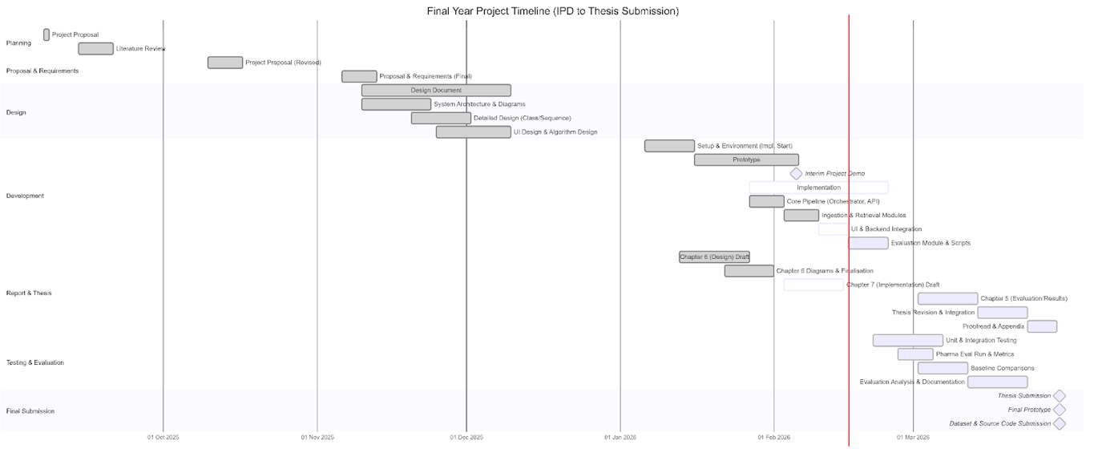

References
Asai, A., Wu, Z., Wang, Y., Sil, A. and Schlichtkrull, M. (2023) Self-RAG: Learning to Retrieve, Generate, and Critique through Self-Reflection. Available at: https://arxiv.org/abs/2310.11511.
BaranziniLab (2024) 'Biomedical knowledge graph-optimized prompt generation for large language models', Bioinformatics, 40(9).
Chen, J., Wang, L. and Zhang, Y. (2022) 'A Generic Retrieval-Augmented Generation Framework for Enterprise Knowledge Bases', in Proceedings of the 2022 International Conference on Information and Knowledge Management (CIKM), Atlanta, GA, USA, pp. 112-121.
Day, A. (2024) Unlocking Hybrid Search: A Deep Dive into Allen Day's Solr MCP Server. Available at: https://skywork.ai/skypage/en/hybrid-search-solr-mcp/ (Accessed: 30 October 2025).
Es, S., et al. (2023) RAGAs: Automated Evaluation of Retrieval Augmented Generation. Available at: https://arxiv.org/abs/2309.15217.
Fanconi, T., Schaar, M. and Jitkrittum, W. (2024) Towards a Cascaded LLM Framework for Cost-effective Human-AI Decision-Making. Available at: https://arxiv.org/abs/2405.15838.
Gao, P., et al. (2024) 'RAG-based Text2SQL Business Intelligence System Based on Retrieval-Augmented Generation (RAG)', DOAJ, 2024.
Gu, Y., et al. (2021) 'Domain-Specific Language Model Pretraining for Biomedical Natural Language Processing', ACM Transactions on Computing for Healthcare, 3(1), pp. 1-23.
Gupta, R. and Li, X. (2023) 'Multimodal Fusion for Financial Report Analysis: Combining Textual and Tabular Data', Journal of Financial Data Science, 5(3), pp. 45-60.
Hao, S., et al. (2024) 'SQL-RAG: A RAG Framework for SQL Database Querying', in Proceedings of the 2024 ACM SIGMOD International Conference on Management of Data.
Herzig, J., et al. (2020) 'TAPAS: Weakly Supervised Table Parsing via Pre-training', in Proceedings of the 58th Annual Meeting of the Association for Computational Linguistics (ACL), pp. 4320-4333.
Lee, J., Yoon, W., Kim, S., Kim, D., Kim, S., So, C.H. and Kang, J. (2020) 'BioBERT: a pre-trained biomedical language representation model for biomedical text mining', Bioinformatics, 36(4), pp. 1234–1240.
Lewis, P., et al. (2020) 'Retrieval-Augmented Generation for Knowledge-Intensive NLP Tasks', in Advances in Neural Information Processing Systems 33 (NeurIPS 2020), pp. 9459-9474.
Liu, P., et al. (2023) 'A Comprehensive Survey of Text-to-SQL', ACM Computing Surveys, 56(2), pp. 1-38.
Manjee, S. (2024) From PDF tables to insights: An alternative approach for parsing PDFs in RAG. Available at: https://www.elastic.co/search-labs/blog/alternative-approach-for-parsing-pdfs-in-rag (Accessed: 30 October 2025).
Rodriguez, F., Patel, S. and Kim, M. (2023) 'Cost-Effective Query Routing for Large Language Model Cascades in Conversational AI', in Advances in Neural Information Processing Systems 36 (NeurIPS 2023), pp. 2015-2025.
Sadekar, O. (2024) Natural Language to SQL with LangChain + RAG: A Practical Guide. Available at: https://medium.com/@OmkarSadekar/natural-language-to-sql-with-langchain-rag-a-practical-guide-1841616c8523 (Accessed: 30 October 2025).
Sahoo, S., et al. (2024) Balancing Content Size in RAG-Text2SQL System. Available at: https://arxiv.org/abs/2502.15723.
Vaswani, A., et al. (2017) 'Attention Is All You Need', in Advances in Neural Information Processing Systems 30 (NIPS 2017), pp. 5998-6008.
Yue, M., Zhao, J., Zhang, M., Du, L. and Yao, Z. (2023) 'Large Language Model Cascades with Mixture of Thoughts Representations for Cost-efficient Reasoning', in International Conference on Learning Representations (ICLR).
Zhang, H., et al. (2024) Cost-Saving LLM Cascades with Early Abstention. Available at: https://arxiv.org/abs/2502.09054.

